**MEAL PLANNER**

**(By Semester 5th of 3rd year MSC (2019-20))**

PROJECT ID: 34

PAKSHAL SHAH - 3069

HET SHAH - 3146



*Submitted To: K S School of Business Management*

*MSC. – Computer Applications and Information Technology*

**I. Acknowledgement**

**­**

* The success and final outcome of this project required a lot of guidance and assistance from our mentor and we are extremely fortunate to have got this all along the completion of our project work. Whatever we have done is only due to such guidance and assistance and we would not forget to thank them.
* We respect and thankful to K.S.S.B.M., for giving us an opportunity to do the project work and providing us all support and guidance which made us completes the project on time.

|  |  |  |  |
| --- | --- | --- | --- |
| **INDEX** | | | |
| **Sr. No** | **Title** | | |
| **1.** | **Introduction** | | |
|  | 1.1 | Organization Profile | |
|  | 1.2 | System Details | |
|  |  | 1.2.1 | Existing System |
|  |  | 1.2.2 | Proposed System |
|  | 1.3 | Scope Of System | |
|  | 1.4 | Objectives | |
| **2.** | **Proposed System Requirement Gathering** | | |
|  | 2.1 | Stakeholder Of System | |
|  | 2.2 | Requirement Gathering Technique Used | |
|  | 2.3 | Consolidated List of Requirement | |
|  | 2.4 | Project Definition | |
| **3.** | **System Management & Planning** | | |
|  | 3.1 | Feasibility Study | |
|  |  | 3.1.1 | Technical |
|  |  | 3.1.2 | Operational |
|  |  | 3.1.3 | Economical |
|  | 3.2 | Hardware Software Requirement | |
|  | 3.3 | System Planning | |
|  |  | 3.3.1 | Work Breakdown Structure |
|  |  | 3.3.2 | Gantt Chart |
|  | 3.4 | Project Model | |
| **4.** | **System Analysis & Design** | | |
|  | 4.1 | UML Diagrams | |
| ­­­ | 4.2 | System Flow Diagram | |
|  | 4.3 | Data Dictionary | |
|  | 4.4 | User Interface | |
|  | 4.5 | System Navigation | |
| **5.** | **Input / Output Design** | | |
| **6** | **Testing** | | |
| **7** | **Summary** | | |

**CH – 1 INTRODUCTION**

* 1. **ORGANIZATION PROFILE**

**Name:** Dash web lab

**Address:** 304, Saumya square, opposite Mahalaxmi Temple, Near Govardhan Party Plot, Thaltej, Ahmedabad - 380009



**About:** They do many types of animation like motion animation, 2D animation, cartoon animation etc. They also develop website to other company or other customer according to their requirement. They also develop mobile application and also doing branding / designing

**1.2 SYSTEM DETAILS**

* Our system does work for providing meal for customer.
* We also provide diet food for the customer.
* We provide calorie option in the food for the customer.
* We provide multiple option for choosing the food like breakfast, lunch, dinner all or any one or any two what they want.
* Meal plan system is mostly providing for different type of meal like low calorie, balance food, vegetarian, high protein, Jain etc...
* We provide two type of food delivery.

1. Home delivery
2. Pick up

**1.2.1 EXISTING SYSTEM**

* They do not use any software before that, so they do all work manually.
* They take order from phone calls and some customer order from there.
* They work of accounting, food supplying doing manually.
* There is very difficult to Memorized about all order of all customer.
* Now they want to do their business online so they want to create their software.
* So, we create a software for them to increase their business.

**1.2.2 PROPOSED SYSTEM**

* The proposed system consists of full online data entry with online validation on the field and referential checking.
* The goal of this system is to bring down the workload with the increased efficiency and to speed up the activities.
* The major activity of online sales and inventory management system is to provide online communication between the users of the system.
* Availability of the information immediately after data captures.
* Minimize inventory costs and maximize sales and profits.
* Automation of manual task.

**1.3 Scope of Meal Planning**

* In today’s world, almost all kinds of businesses have started opening shops online. You can see shoes and clothes being sold online. So, it is only a matter of time before food was sold online.
* The revenue got by selling food online is going to increase in every major country.
* Thus, promoters who can develop a superb online food ordering software will be able to reap profits.
* Nowadays, people used to buy food either directly from the restaurants or order over the phone. However, this has changed and people have started ordering online.
* Ordering food online has two sides. The supplier side and the customer side.
* On the supplier side, you have restaurants, fast food joints and other food outlets. These food outlets register on an [**online food ordering app**](https://www.agriya.com/blog/2017/08/29/cost-to-develop-online-food-ordering-website/). After registration, they display their goods along with the prices.
* On the customer side, you have people who eat at these food outlets. These people browse through the app and choose the items they like and order them.
* System will be used by people who want to know what type of food serving that are suitable for them and want to manage their diet better. It can also be used by people who works relate to the diet field.
* As it can be seen that the online food industry is going to at a rapid pace throughout the world. Every year the number of people who order food online has gone up.
* During last few years, there have been many start-ups in India. This is because many Indians have started ordering food online
* People are now trying to replicate the success of apps like Zomato.

**1.4 Objectives of Meal planning**

* Security of data. Data are well protected for personal use.
* Ensures data accuracy during order placement process.
* Minimized manual data entry.
* Greater efficiency since data processing is very fast.
* User friendly and interactive interface with provision for customer to view menus and have a visual confirmation that the order was place correctly.
* Minimized time requirement during the order placement process.
* Greatly simplifies the ordering process for both customer and restaurant.

**CH – 2 PROPOSED SYSTEM REQUIREMENTS GATHERING**

**2.1 STAKEHOLDER OF SYSTEM**

There are two stockholder of the system there are following.

1. System admin
2. System user
3. System admin:

* A system admin is a person who is handle of the system.
* Admin handle all the security of the system.
* Also, admin handle all the order that customer has apply for their meal.
* Admin accept all the order of customers. Admin handle all the diet food, balance food, etc.
* System short out all the food by calorie vies.
* Admin also handle that customer want to home delivery or pick up from there.
* Admin also handle which customer select how many days of the week.

1. System user:

* There are two type of system user .one is regular user and another is a guest user.
* Regular user can order meal daily or weekly.
* Guest user who is book only once or ire-regular. They visit the site only one time or sometimes they are not a regular customer.
* Customer also book order what they want to order if they order weekly.

**2.2 REQURITEMENT GATHERING TECHNIQUE**

In the business environment, it is required to have an effective way of market research to understand what a customer wants and how to be successful over competitors. We need to focus on how to make the users to achieve their goals. The Requirements gathering process will help in understanding the needs of a customer, especially in the IT industry.

* Interviews
* Questionnaires
* Observations
* Facilitated Workshops
* Focus groups
* JAD
* Brainstorming
* Prototyping
* Documentation analysis
* We are used questionnaires technique for our system.
* The question we asked to the admin that are following

1. What are the functionalities that you are require in the application?
2. How many types of food are you provide to customer?
3. What types of food are you providing for the customer?
4. How you create a diet plan?
5. How customer can pay the bill?
6. What is the delivery type you provide for customer?
7. What is the time of your restaurant?

**2.3 CONSOLIDATED LIST OF REQUIREMENTS**

* The system will be designed to be user friendly.
* The user friendly and interactive interfaces design helps to achieve this by enabling customers to easily browse through the menus place orders with just a few clicks and also allows restaurant employees to quickly go through the orders as they are placed and produce the necessary items with minimal delay and confusion.
* The system will be simple to use.
* Functional requirements define the capabilities and functions that a system must be able to perform successfully. The functional requirements of this online ordering system include:
* The system shall enable the customer to view the products menu, create an account, login to the system and place an order.
* The customer shall specify whether the order is to be picked up or delivered.
* The system shall display the food items ordered, the individual food item prices and the payment amount calculated.
* The system shall prompt customer to conform the meal order.
* The system shall provide visual confirmation of the order placement
* The system shall enable the manager to view, create, edit and delete food category and descriptions
* The system shall allow confirmation of pending orders.
* The system shall allow the manager to update additional information (description, photo, ingredients etc.) for a given food item.
* The system shall allow the manager to update price for a given food item.

**2.4** **PROJECT DEFINITION**

* We provide the web site of meal planning for our customer. They want to increase their business so they want to help online business.
* We provide good meal for the customer. We provide different types of diet food, balance food, low calorie food, protein etc.
* Main purpose of our system is that we can provide calorie wise food to customer. If customer want to low calorie meal then they can select low calories food. So the customer maintain their body.
* We provide two types of providing meal first is home delivery and second is pick up so customer choose any one of them.
* We provide also select days. Customer select one day or three day or whole week.
* We also provide different type of meal in day like lunch, dinner, breakfast what customer want to select they can select.

**Ch 3: SYSTEM MANAGEMENT SYSTEM**

**3.1 Feasibility study**

The main aim of the feasibility study is to determine that it would be financially and technically feasible to develop the product or not. The purpose of the feasibility study is not to solve the problem, but to determine whether the problem is worth solving.

**3.1.1 Technical Feasibility**

The technical feasibility study compares the level of technology available in the software development firm and the level of technology required for the development of the product. Here the level of technology consists of the programming language, the hardware resources, other software tools etc.

* It just requires the normal browser to use our system.
* The organization has already purchased required gadgets.
* The facility to produce outputs in a given time.
* Facility to communicate data to distant locations.

Hence, the proposed system is technically feasible.

**3.1.2 Operational Feasibility**

Operational feasibility study tests the operational scope of the software to be developed. It is checked that if the system is actually can be useful when implemented. Our system is operationally feasible in the following ways:

* Since the users are well educated and know the importance of computer in the day to day life, they will show a positive response to our system.
* The system does not have specific hardware/software requirements. Any user will be able to use this website on its comprehensive desktop/mobile phone.

**3.1.3 Economical Feasibility**

The economic feasibility study evaluates the cost of software development against the ultimate income or benefits gets from the developed system. There must be scopes for profit after the successful Completion of the project.

**The system is economically feasible because:**

* Our system is not much costly to develop.
* There is no extra economical cost because the system is developed with an open source technology.
* It is easy to use and understand therefore there is no need to appoint an operator to use the system.
* The organization is ready to invest in the proposed system because it is being developed in the latest technology and will be very fast for the users to transfer or share the information using the system.

**3.2 HARDWARE – SOFTWARE REQUIREMENTS**

|  |  |
| --- | --- |
| SOFTWARE REQUIREMENTS | |
| PLATFORM | **PHP** |
| FRONT-END | **BOOTSTRAP, HTML, CSS** |
| BACK-END | **PHP** |
| IDE | **SUBLIME** |
| TOOLS | **XAMPP** |
| OTHER TOOLS | **WORD, POWERPOINT, VISIO** |

|  |  |
| --- | --- |
| HARDWARE REQUIREMENTS | |
| PROCESSOR | **INTEL P4 AND HIGHER AND/OR EQUIVALENT PROCESSOR SYSTEM** |
| HARD-DISK | **40 GB OR ABOVE** |
| RAM | **512 MB AND ABOVE** |

**3.3 PROJECT PLANNING**

**3.3.1 WORK BREAKDOWN STRUCTURE**

**3.3.2 GANTT CHART**

|  |  |  |  |  |  |  |  |  |  |
| --- | --- | --- | --- | --- | --- | --- | --- | --- | --- |
| Activities | Aug | Sep | Oct | Nov | Dec | Jan | Feb | Mar | Apr |
| Project Definition |  |  |  |  |  |  |  |  |  |
| Requirement  Gathering |  |  |  |  |  |  |  |  |  |
| Planning |  |  |  |  |  |  |  |  |  |
| Analysis |  |  |  |  |  |  |  |  |  |
| Designing |  |  |  |  |  |  |  |  |  |
| Coding |  |  |  |  |  |  |  |  |  |
| Testing |  |  |  |  |  |  |  |  |  |
| Report |  |  |  |  |  |  |  |  |  |

**3.4 PROJECT MODEL**

**AGILE MODEL**

The Agile thought process had started early in the software development and started becoming popular with time due to its flexibility and adaptability.

**Advantages of Agile Model –**

Agile methods are being widely accepted in the software world recently.

* It is a very realistic approach to software development.
* Promotes teamwork and cross-training.
* Functionality can be developed rapidly and demonstrated.
* Suitable for fixed & changing requirements both.
* Delivers early partial working solutions.
* Minimal rules, documentation easily employed.
* Enables concurrent development and delivery within an overall planned context.
* Easy to manage.
* Gives flexibility to developers

. 3.4.1 Diagram of an agile model process

PREVIOUS ITERATION

EVALUATION

NEXT ITERATION

**Ch. 4: SYSTEM ANALYSIS AND DESIGN**

**4.1 UML (UNIFIED MODELING LANGUAGE)**

**4.1.1 USER USE CASE DIAGRAM**

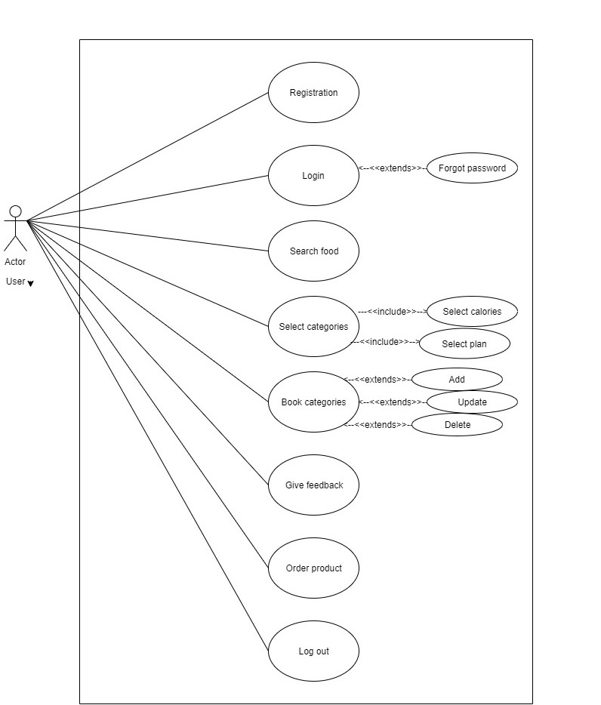

4.1.2 ADMIN USE CASE DIAGRAM

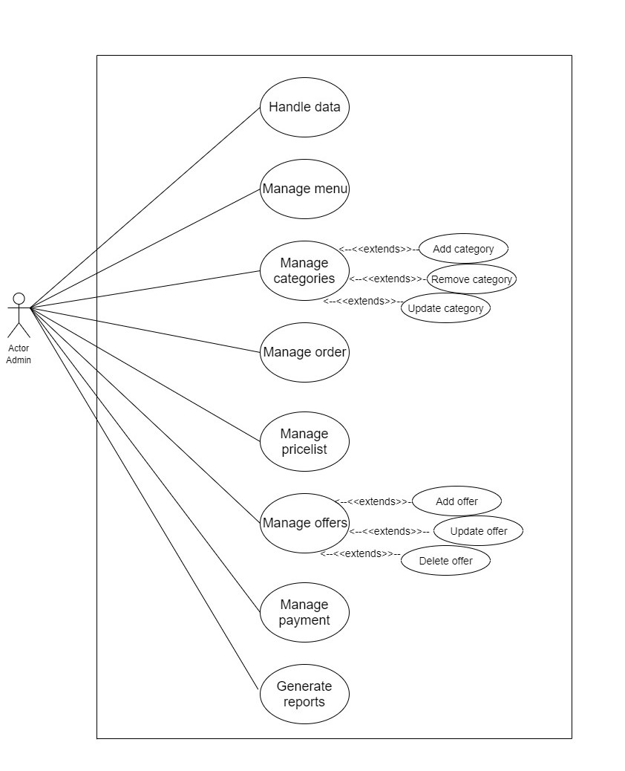

4.1.3 ADMIN ACTIVITY DIAGRAM

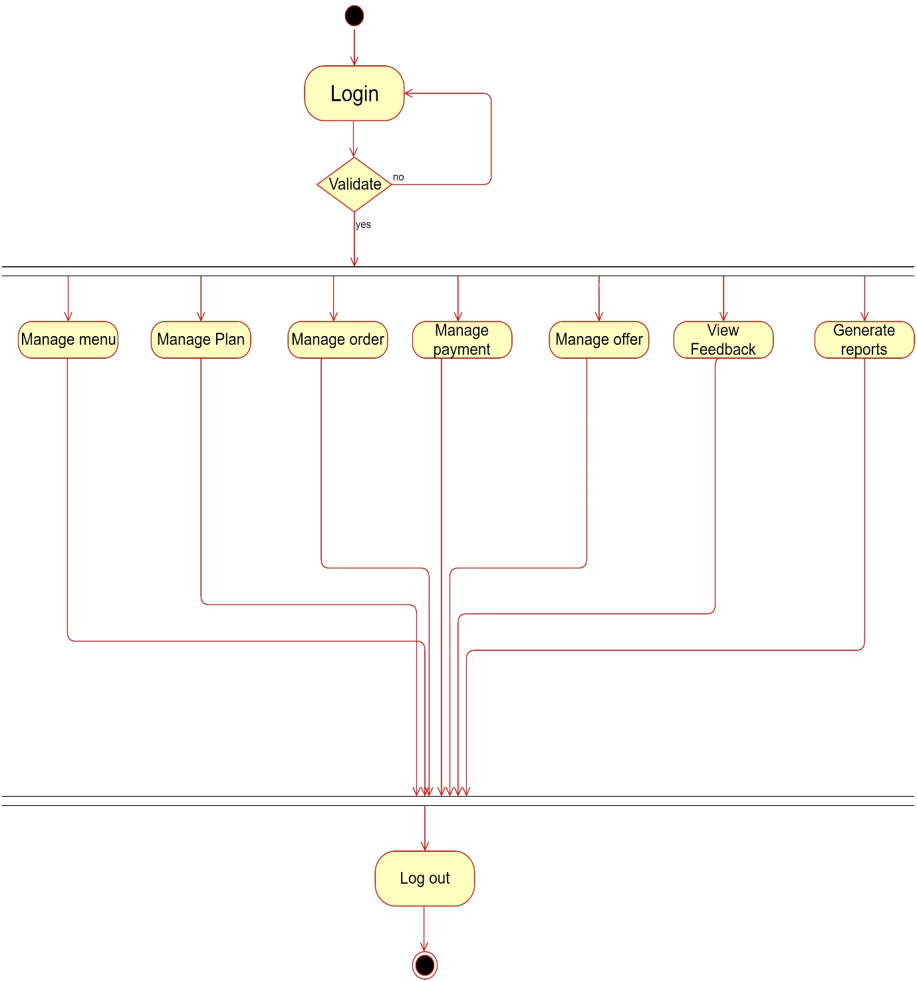

4.1.4 USER ACTIVITY DIAGRAM

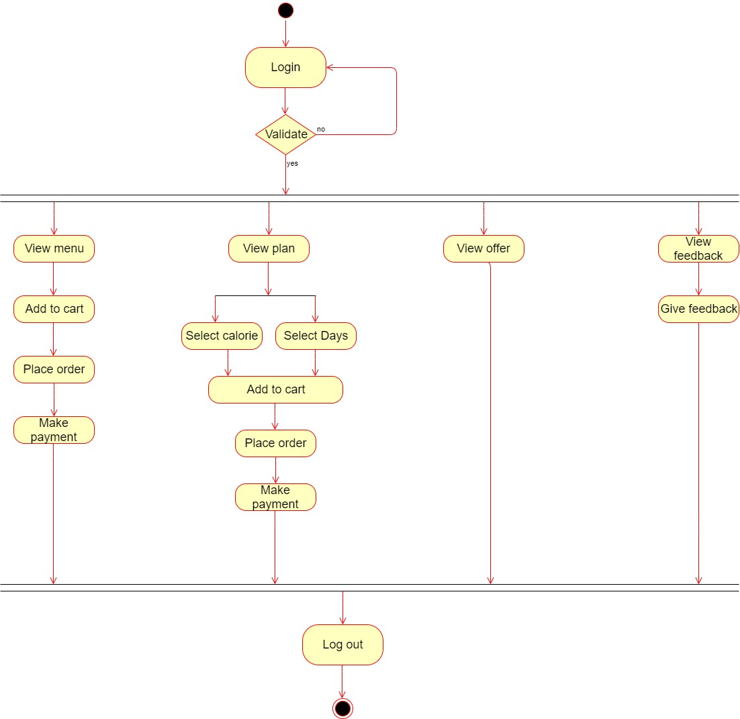

4.1.5 Sequence Diagram for admin

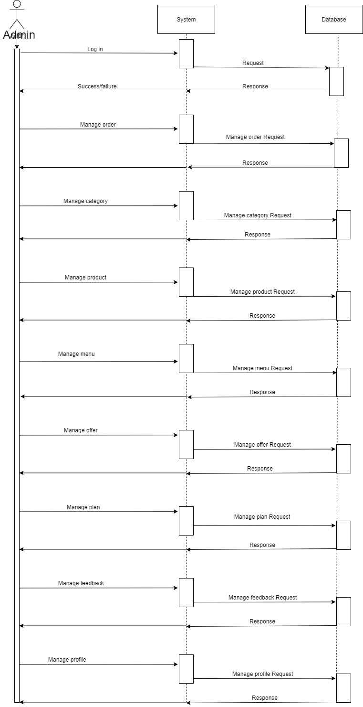

4.1.6 USER SEQUENCE DIAGRAM

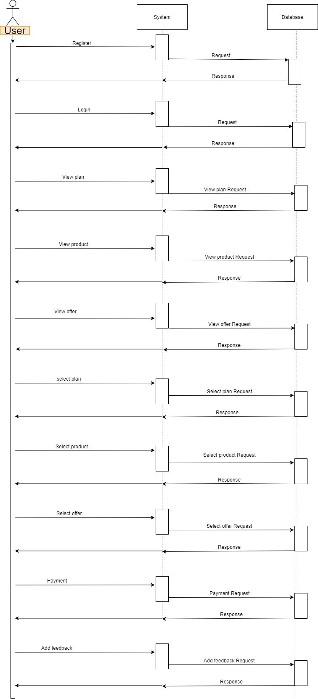

4.1.7 USER CLASS DIAGRAM

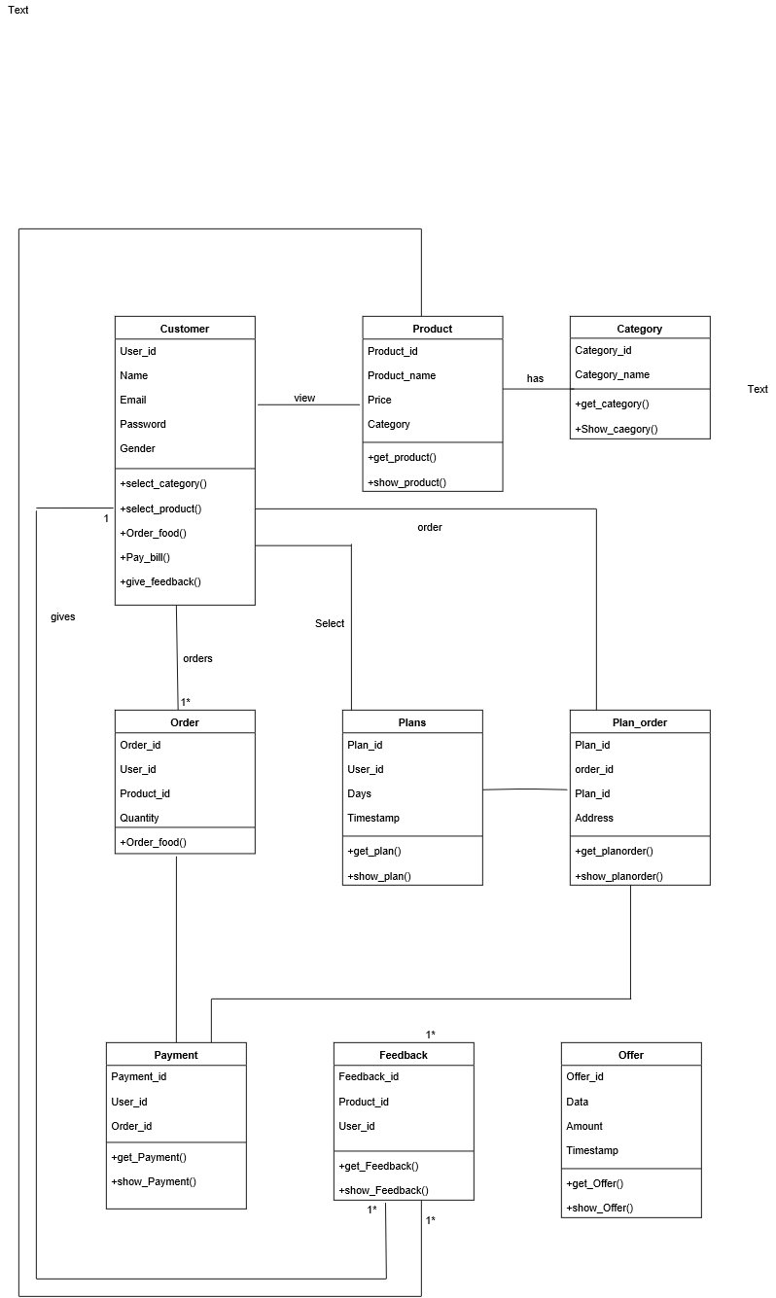

4. 2 ADMIN SYSTEM FLOW DIAGRAM

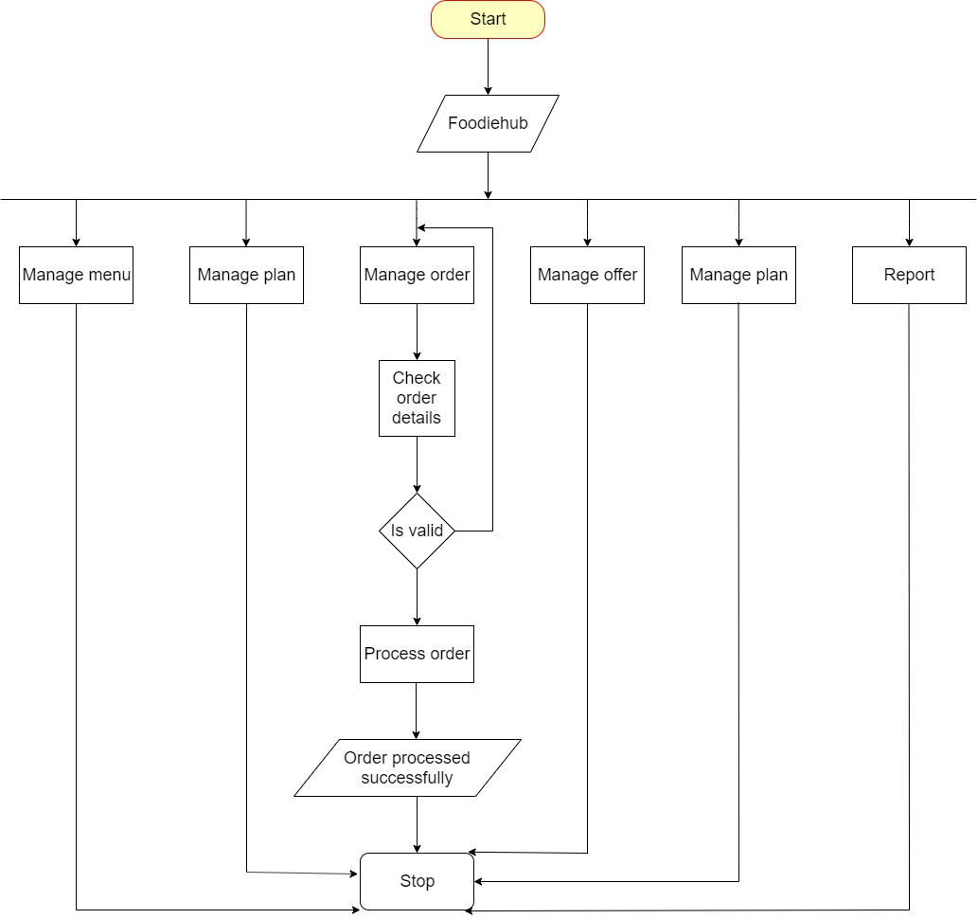

4. 2 ADMIN SYSTEM FLOW DIAGRAM

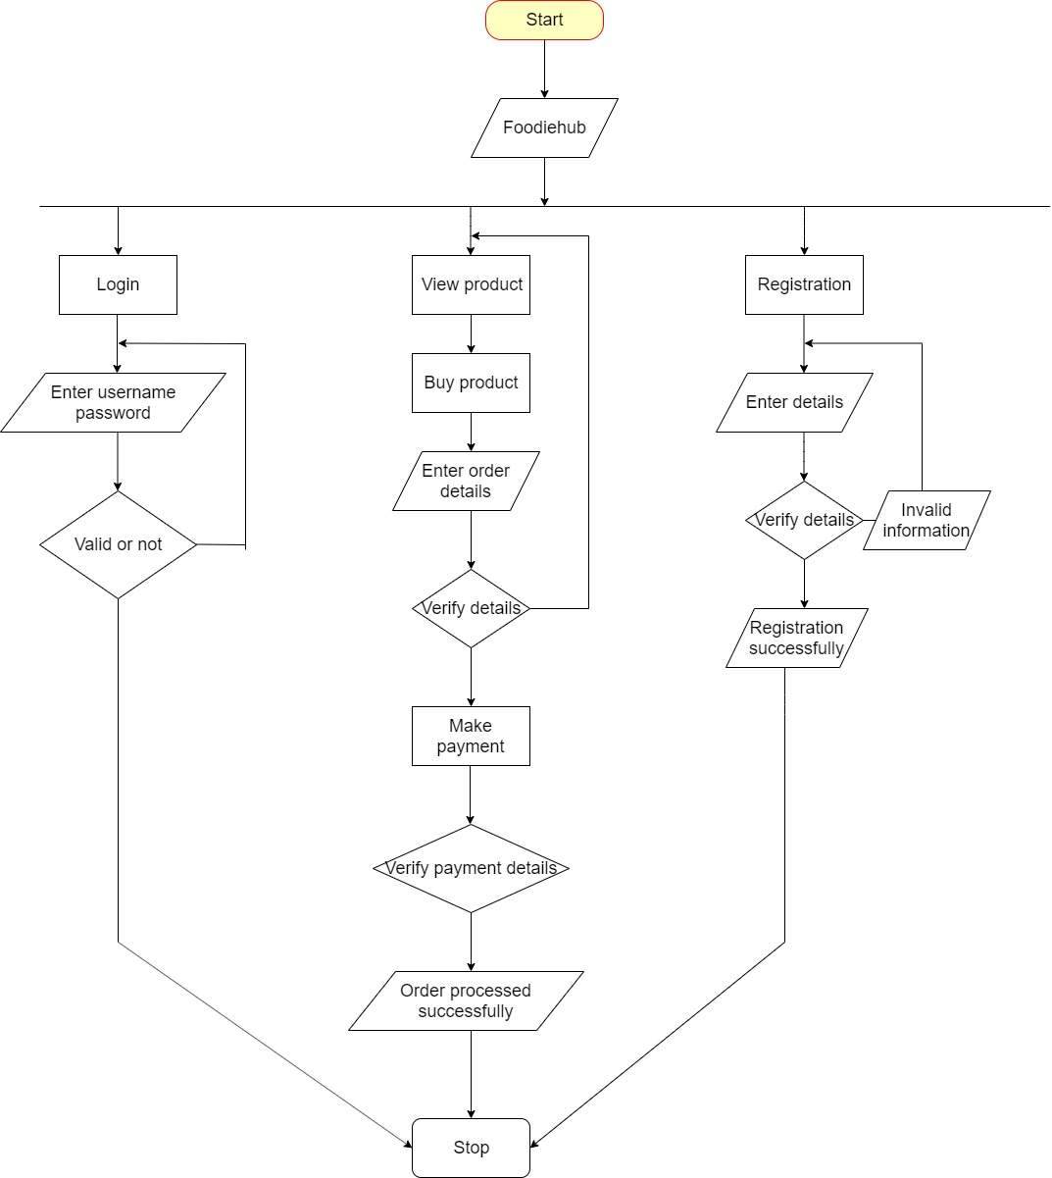

4.3 DATA DICTIONARY

1.Customer

Table Primary Key: C_id

Description: Store the information of the customer

|  |  |  |  |
| --- | --- | --- | --- |
| **Field Name** | **Data Type** | **Constraint** | **Description** |
| C_id | Int (7) | Primary key | Cust_id |
| Name | Varchar (20) | Not null | Name of customer |
| Address | Varchar (100) | Not null | Address |
| Phone_no | Varchar (10) | Not null | Phone number |
| Email | Varchar (20) | Not null | Email id |
| Password | Varchar (20) | Not null | Password |
| Pincode | Int (6) | Not null | Pin code |
| Gender | Boolean | Not null | Male/female |

2.Product

Table Primary Key: P_id

Description: Store the information about the products

|  |  |  |  |
| --- | --- | --- | --- |
| **Field Name** | **Data Type** | **Constraint** | **Description** |
| P_id | varchar(20) | Primary key | Product_id |
| Name | Varchar(20) | Not null | Name of product |
| Image | Varchar(255) | Not null | Image of product |
| Price | Int(5) | Not null | Price of product |
| Calorie | Int (5) | Not null | Calorie of product |
| Food_type | Varchar(255) | Not null | Type of food |
| Category_id | Int(30) | Not null | Category id |
| Food_status | Varchar(255) | Not null | Status of food |
| Description | Varchar(255) | Not null | Description |

3.. Feedback

Table Primary Key: F_id

Description: Feedback given by the customer that are store in this table.

|  |  |  |  |
| --- | --- | --- | --- |
| **Field Name** | **Data Type** | **Constraint** | **Description** |
| F_id | Int (20) | Primary key | Feedback_id |
| C_id | Int (7) | Foreign key | Customer id |
| Description | varchar(20) | Varchar | Description of food |
| P_id | Int(10) | Foreign key | Product id |

4.. order

Table Primary Key: O_id

Description: Store the information about the Order

|  |  |  |  |
| --- | --- | --- | --- |
| **Field Name** | **Data Type** | **Constraint** | **Description** |
| O_ id | Varchar (15) | Primary key | Feedback _id |
| C_ id | varchar (15) | Foreign key | Customer id |
| Quantity | Integer (10) | Varchar | Description of food |
| P_ id | Varchar (15) | Foreign key | Product id |
| Amount | Integer (10) | Not null | Amount of product |

5.. Category

Table Primary Key: Ct_ id

Description: Store the information about the Category

|  |  |  |  |
| --- | --- | --- | --- |
| **Field Name** | **Data Type** | **Constraint** | **Description** |
| Ct_ id | Varchar (15) | Primary key | Category id |
| Name | Varchar (10) | Not null | Name of category |
| Image | Varchar (255) | Primary key | Image of category |

6..Payment

Table Primary Key: Py_id

Description: Store the information about the Payment

|  |  |  |  |
| --- | --- | --- | --- |
| **Field Name** | **Data Type** | **Constraint** | **Description** |
| Py_id | Integer (7) | Primary Key | Payment id |
| O_id | Integer (7) | Foreign key | Order id |
| Cust_id | Integer (7) | Foreign key | Customer id |

|  |  |  |  |
| --- | --- | --- | --- |
| **Field Name** | **Data Type** | **Constraint** | **Description** |
| Offer_ id | Integer (7) | Primary key | Offer id |
| Image | Varchar (255) | Not null | Image of offer |
| Data_ text | Varchar(50) | Not null | Text of offer |
| Amount | Integer (7) | Not null | Amount of discount |
| Start_ date | Time Stamp | Not null | Starting date of offer |
| End_ date | Time Stamp | Not null | Ending date of offer |

7.Offer

Table Primary Key: Offer _id

Description: Store the information about the Offer

8.Plans

Table Primary Key: Plan _id

Description: Store the information about the Plan

|  |  |  |  |
| --- | --- | --- | --- |
| **Field Name** | **Data Type** | **Constraint** | **Description** |
| Plan_id | Integer (7) | Primary key | Plan id |
| Day | Integer (7) | Not null | Days of plan |
| User_id | Integer (7) | Foreign key | User id |
| Created_at | Timestamp | Not null | Time of created time |

9.. Plan order

Table Primary Key: Plan _o _id

Description: Store the information about the order of the plans

|  |  |  |  |
| --- | --- | --- | --- |
| **Field Name** | **Data Type** | **Constraint** | **Description** |
| Plan_ o_ id | Integer (7) | Primary key | Plan order id |
| Order_ id | Integer (7) | Foreign key | Order id |
| Plan_ id | Integer (7) | Foreign key | Plan id |
| Address_ Details | Text | Not null | Address details |
| Zip_ code | Varchar (255) | Not null | Zip code |

4.3 USER INTERFACE

* 1. ADMIN LOGIN PAGE

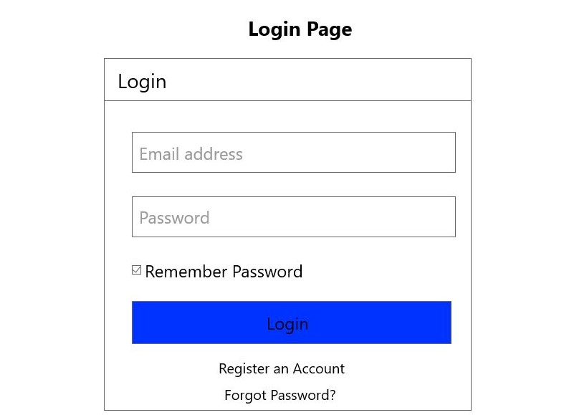

**Description:** Log in page of admin.

2.ADMIN DASHBOARD

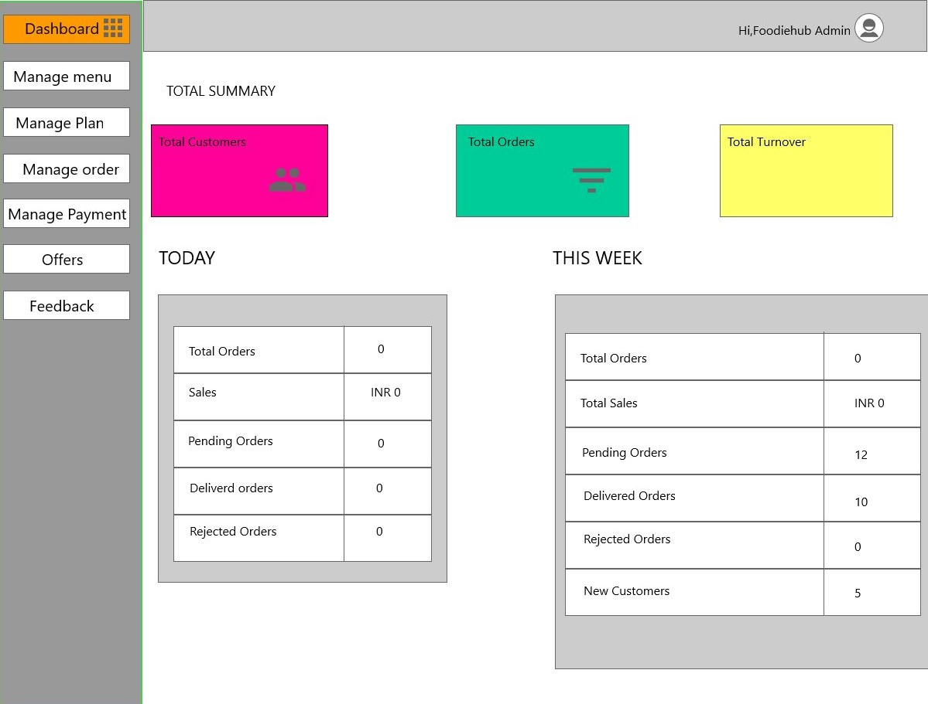

**Description:** Manages all the Modules.

3.. ORDER PAGE ADMIN

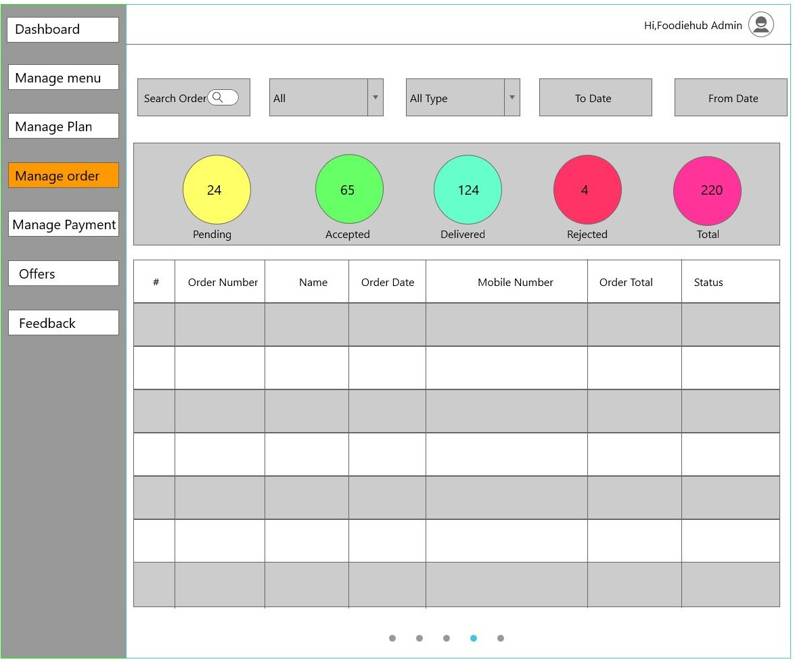

**Description:** Admin can manage all the orders.

4.ADD PRODUCT

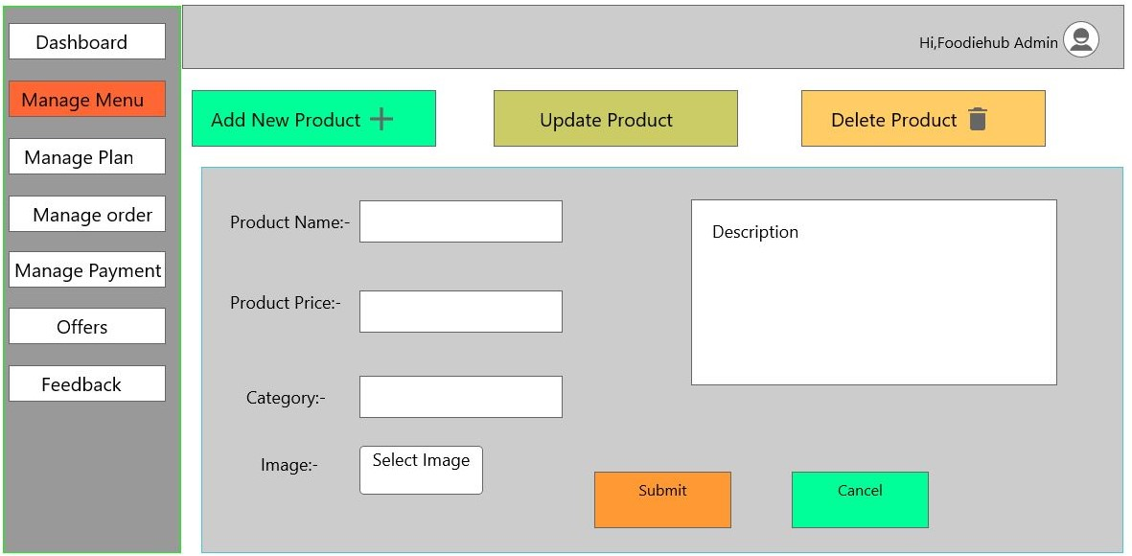

**Description:** Admin can add a new product in the system.

5.ADD PLAN

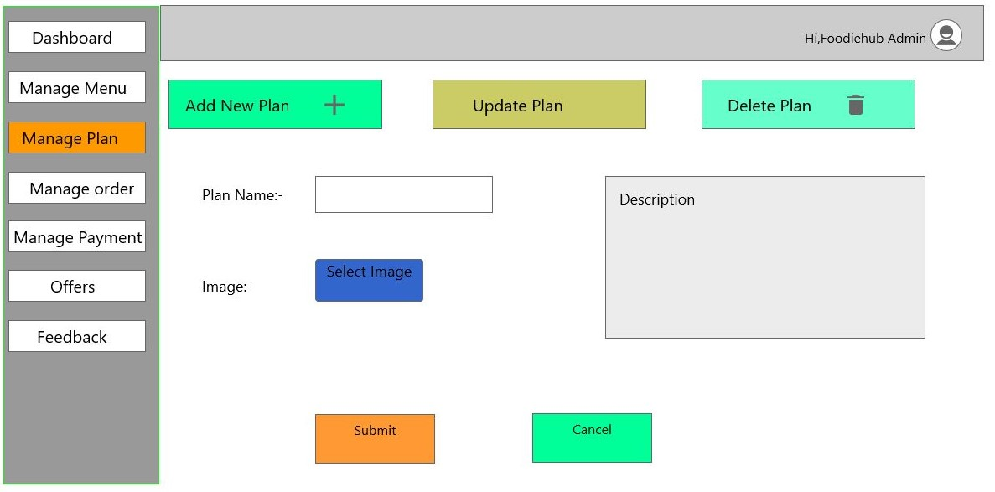

**Description:** Admin can add a new plan in the system.

6.ADD OFFER

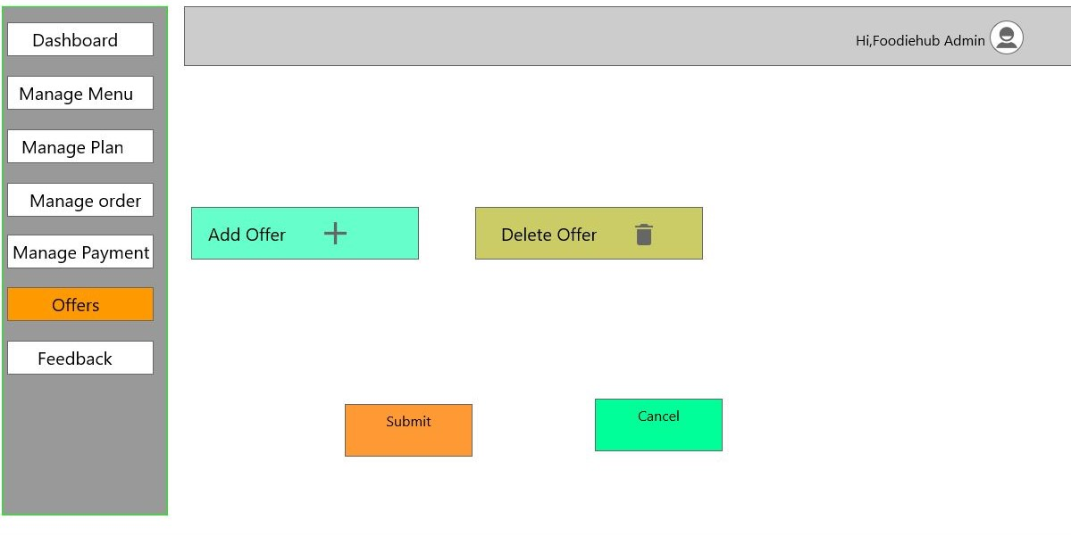

7..USER REGISTER PAGE

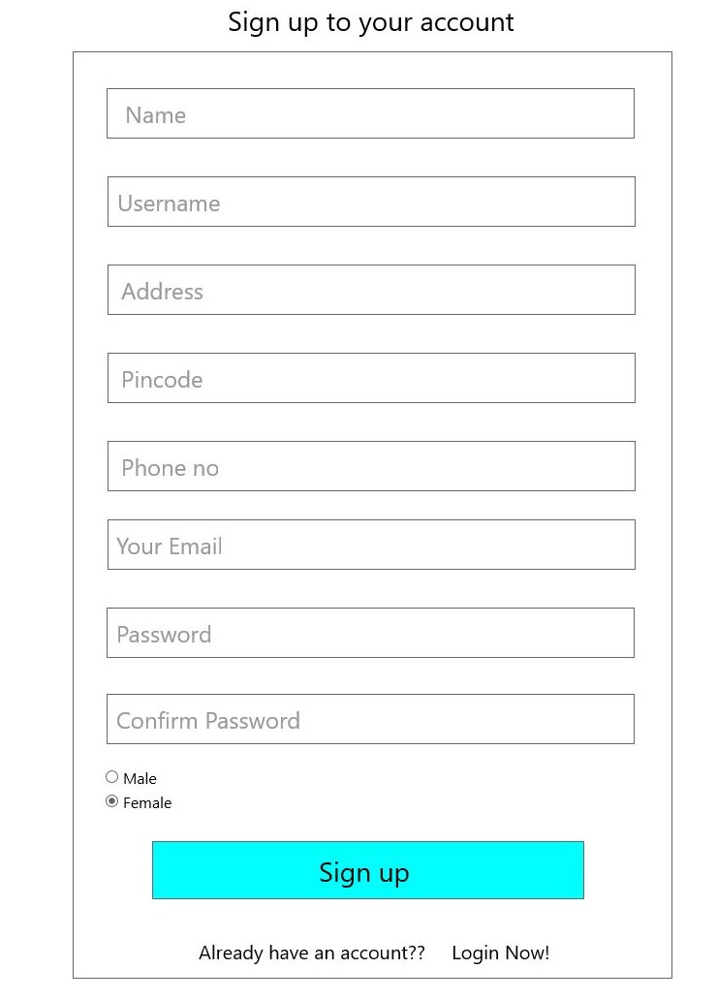**Description:** Registration form for the new users..

8.USER LOGIN PAGE

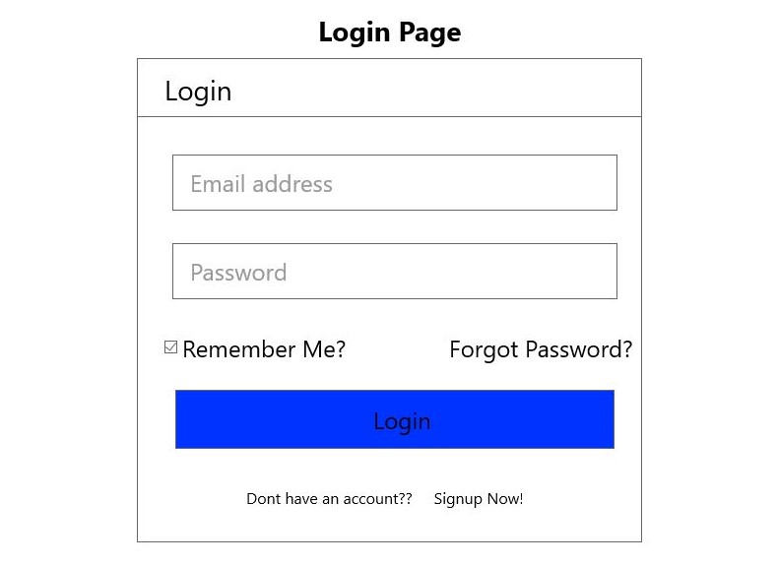

**Description:** Log in for the users.

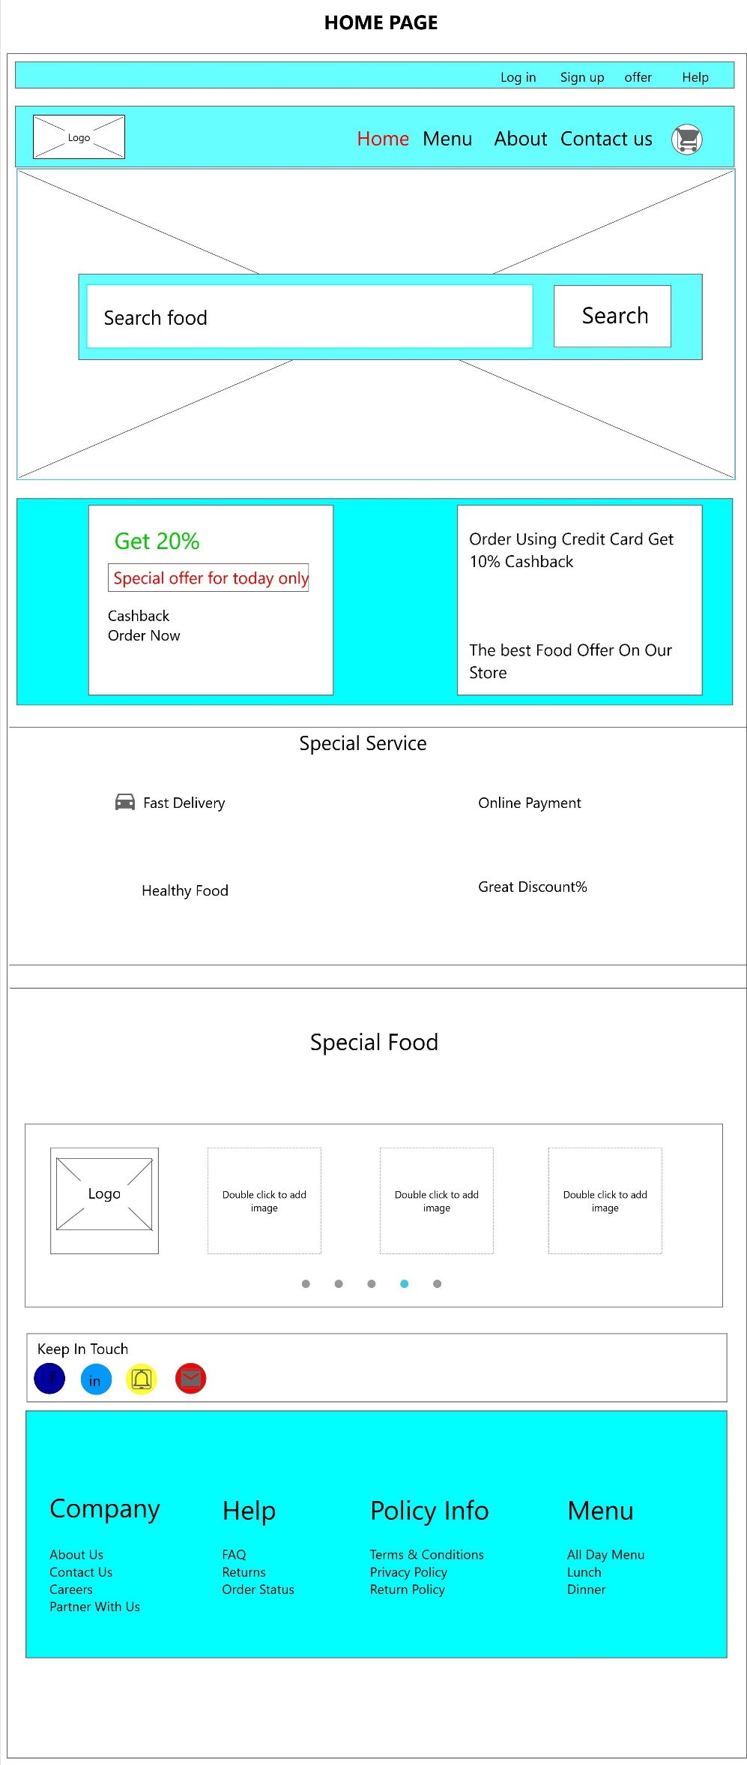

**Description:** The home of the user side.

**Description:** 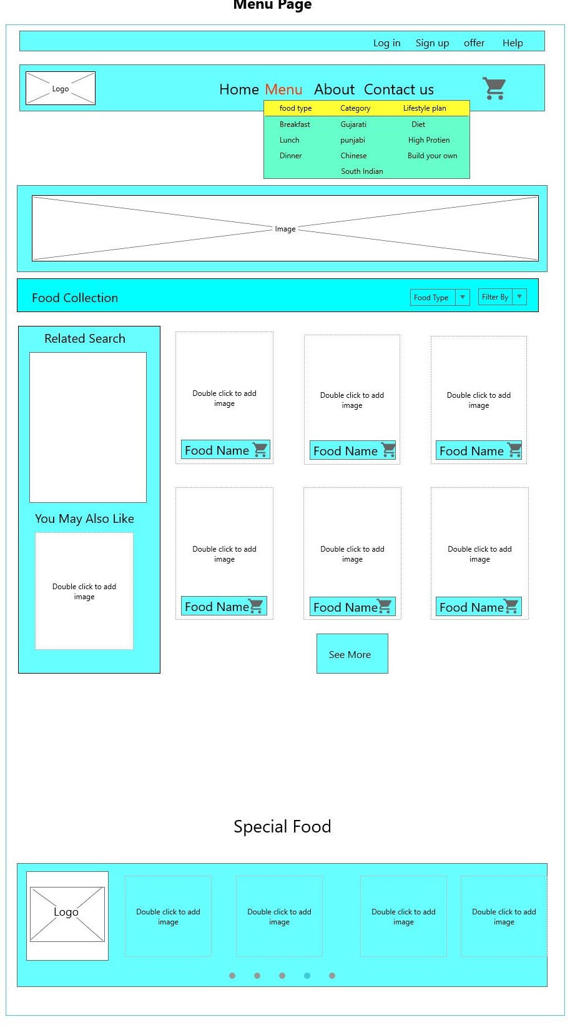Item can be selected by user from this page.

11…USER PLANVIEW PAGE

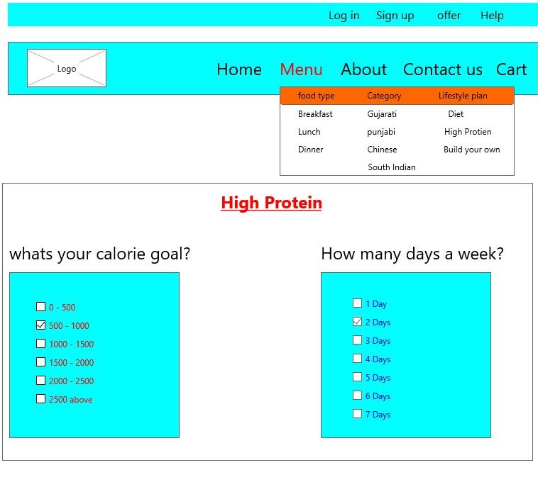

**Description:** User can select calories and days for his plan.

12.Edit plan page

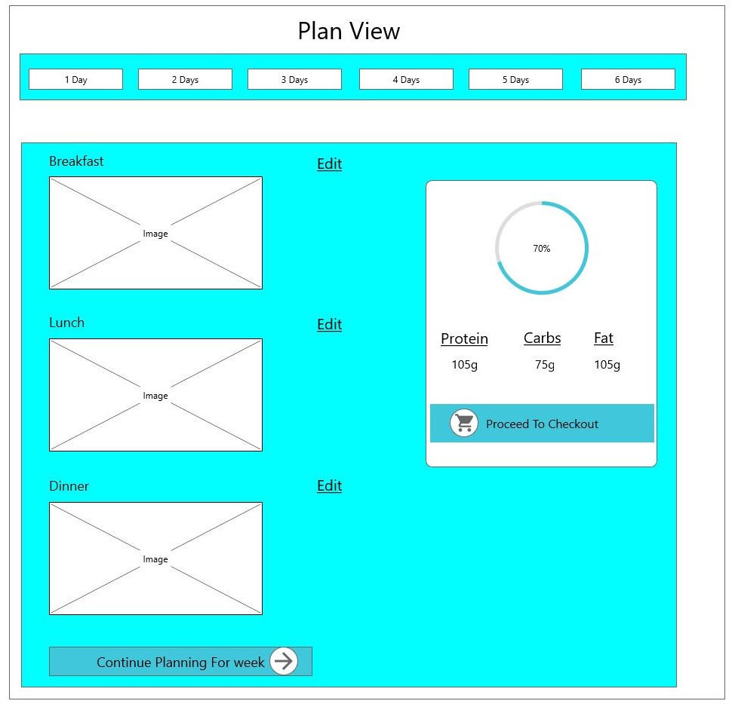

**Description:** User can also change in his menu of the plan.

13..USER OFFER PAGE

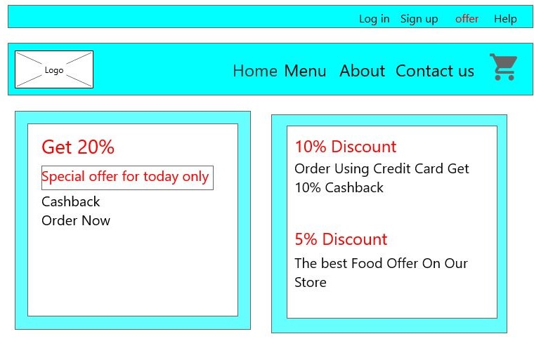

**Description:** This are the offers for the users.

4.5 System Navigation

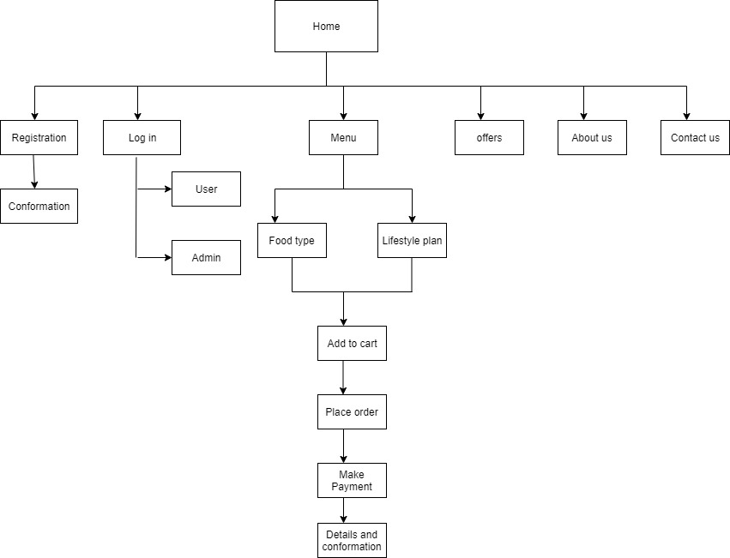

Chapter: -5

Input/output Design

* 1. Admin

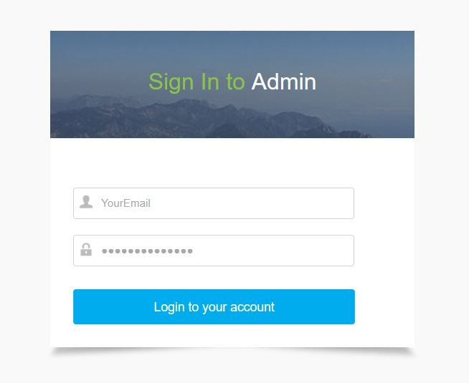

**Description:** This is a log in page of admin.

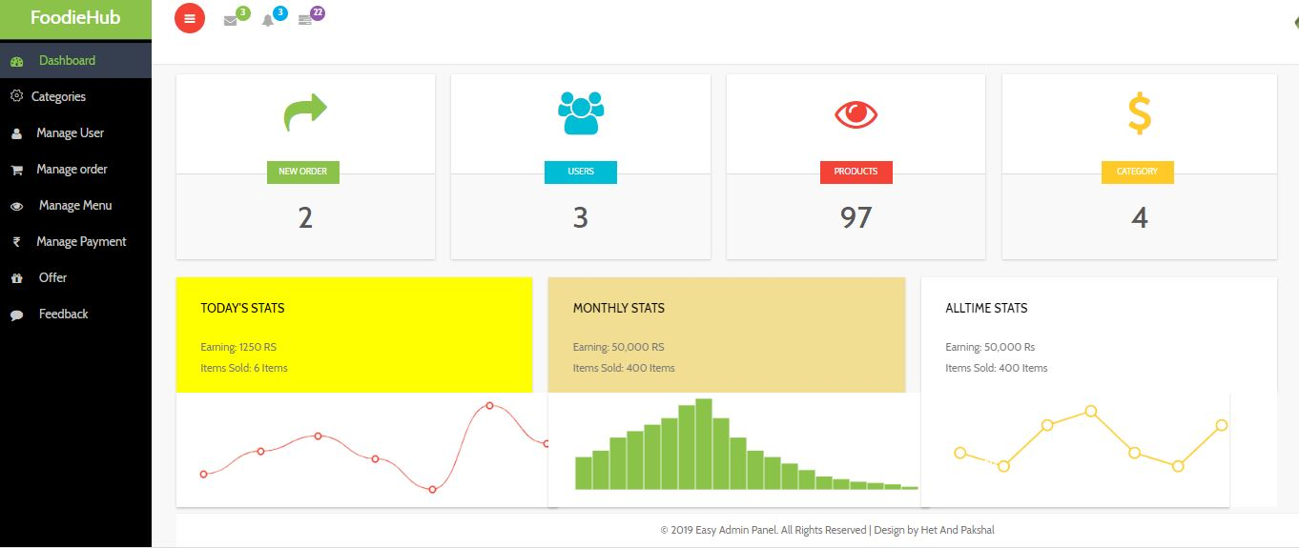

**Description:** This is the dashboard of admin side, this page shows all the statestic of the admin side.

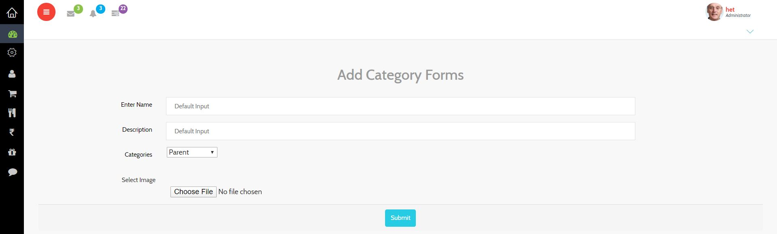

**Description:** This page provides the facility of adding categories for the site.

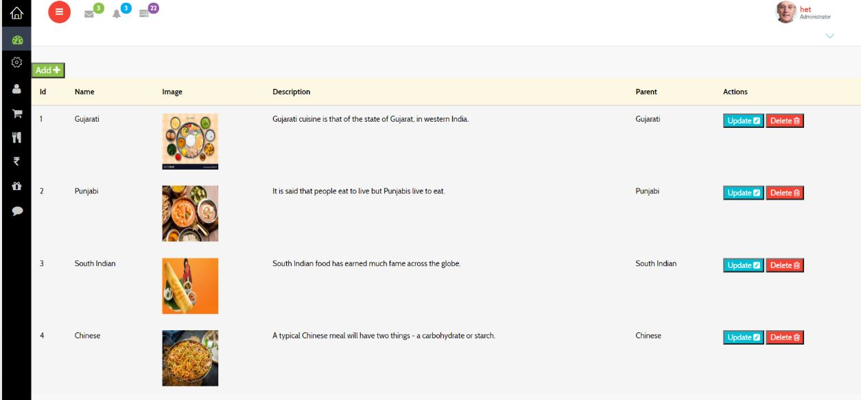

**Description:** This is the category page, this page shows the all category.

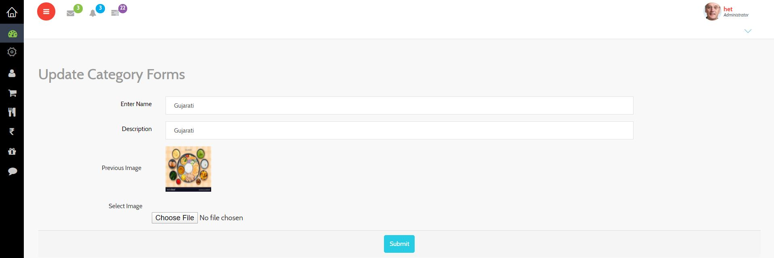

**Description:** This page provides the facility to update or change any or all value in the category.

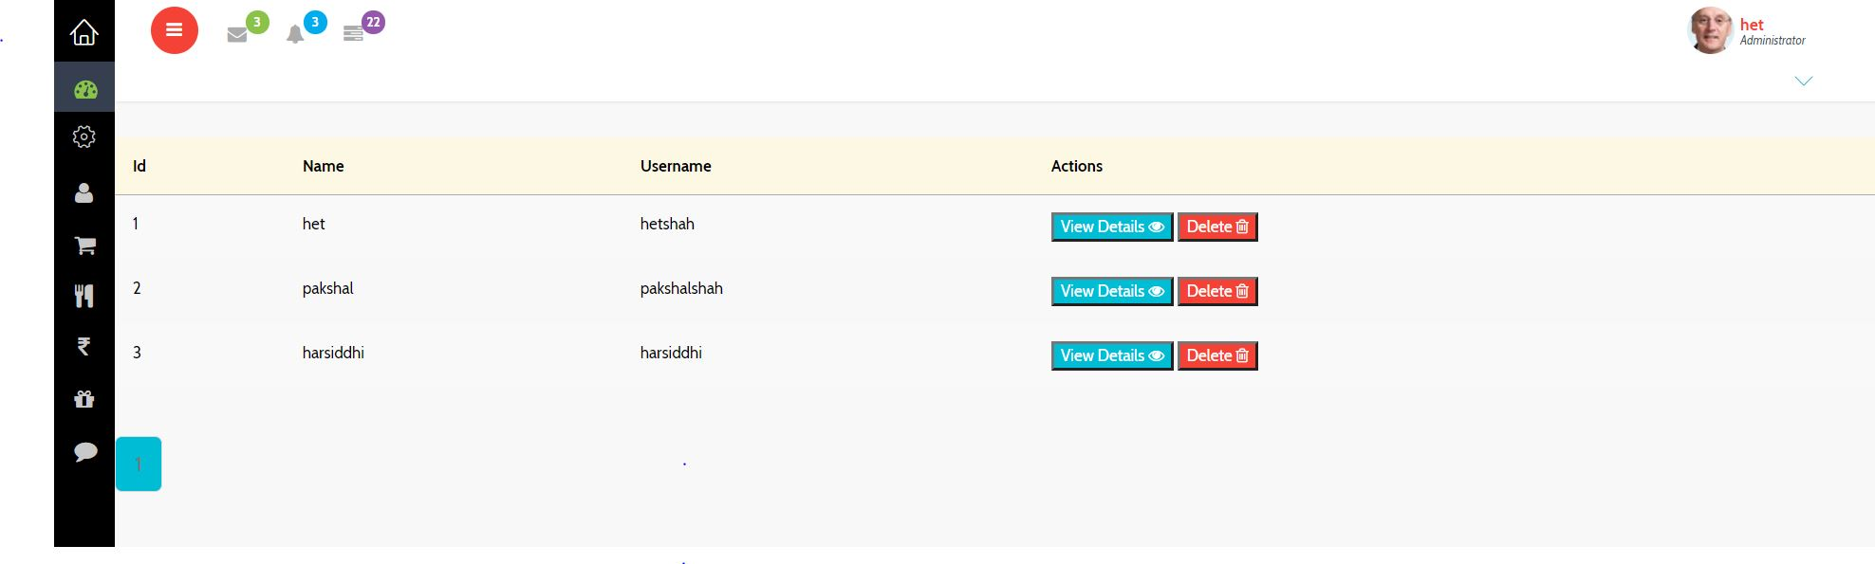

**Description:** This is the user page, this page shows all users of the site.

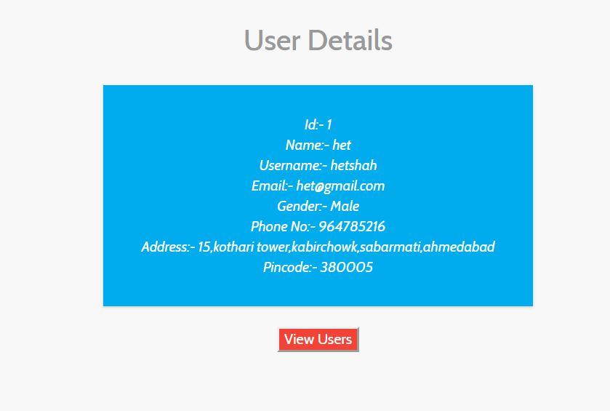

**Description:** when we click on view details button on user page then this page is appear which shows all the details of that user.

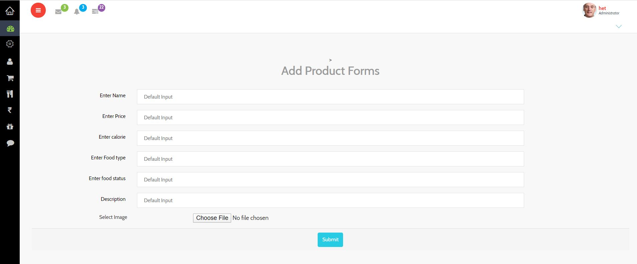

**Description:** This page provides the facility of adding productss for the site.

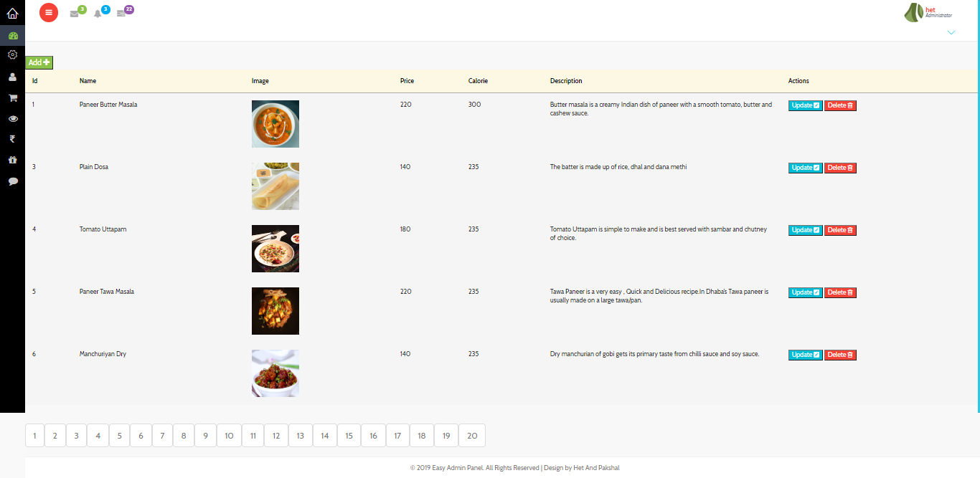

**Description:** This is product page, this page show all the product and also all details about the product.

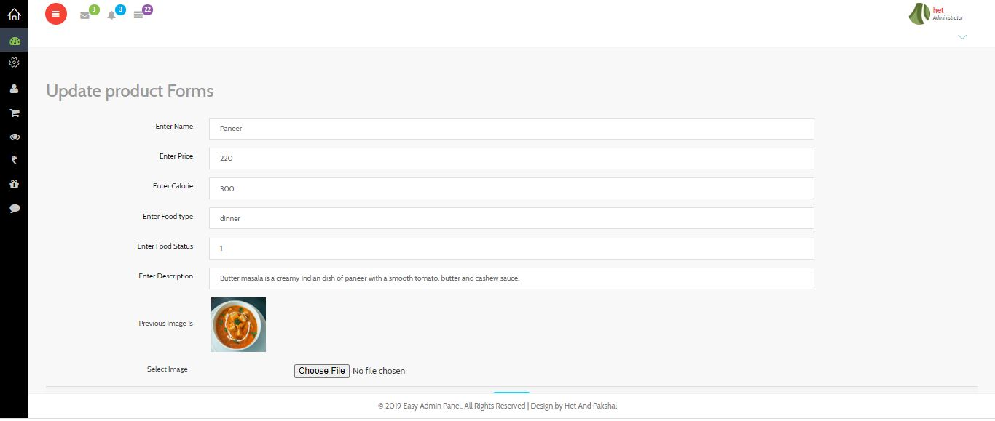

**Description:** This page provide facility to change any value or all the value of the product.

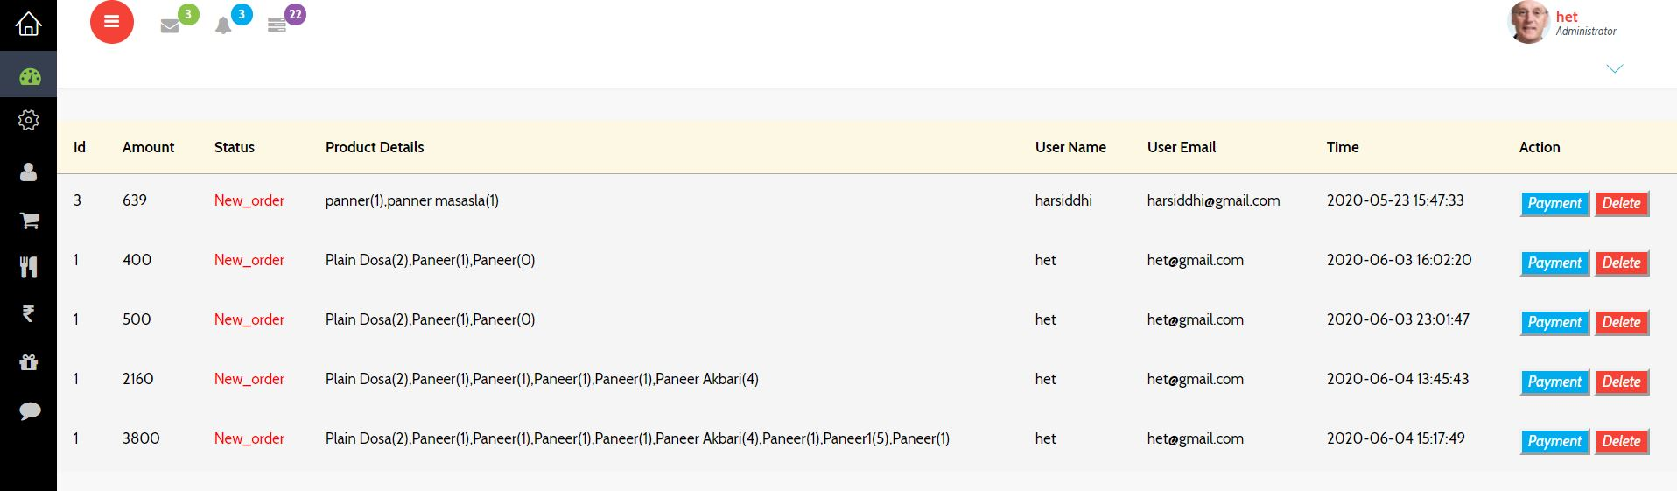

**Description:** This is order page, this page is show all the details about the order which user buy which product and user details. This page also show that order are complete or pending.

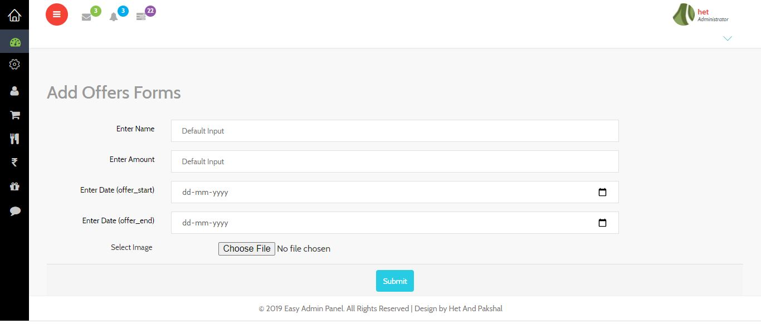

**Description:** This page provide facility to add offer to attract the users.

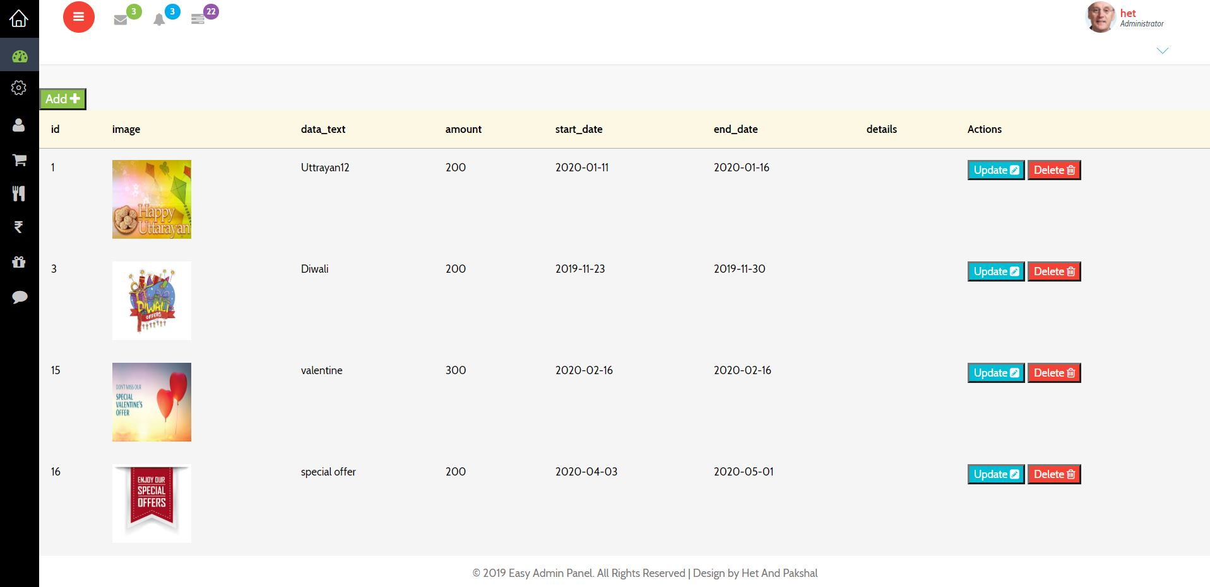

**Description:** This page shows all the offers and details about that offer.

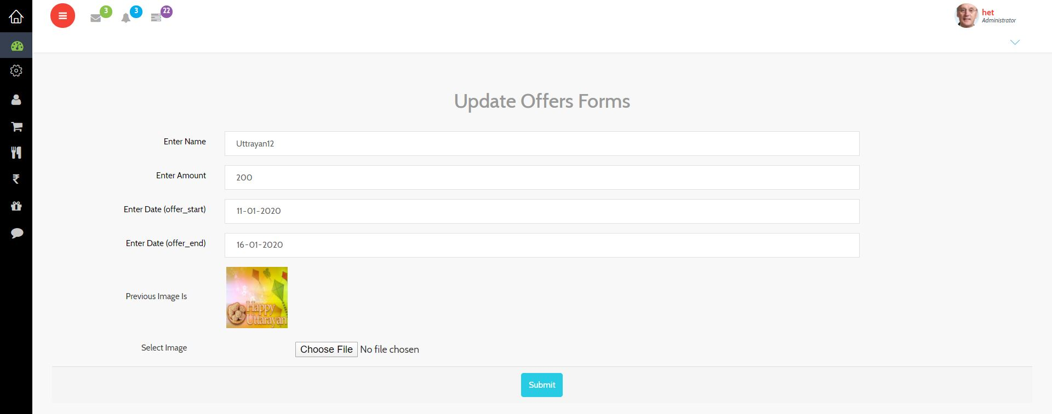

**Description:** This page provides facility to change or update any value or all value in the offer.

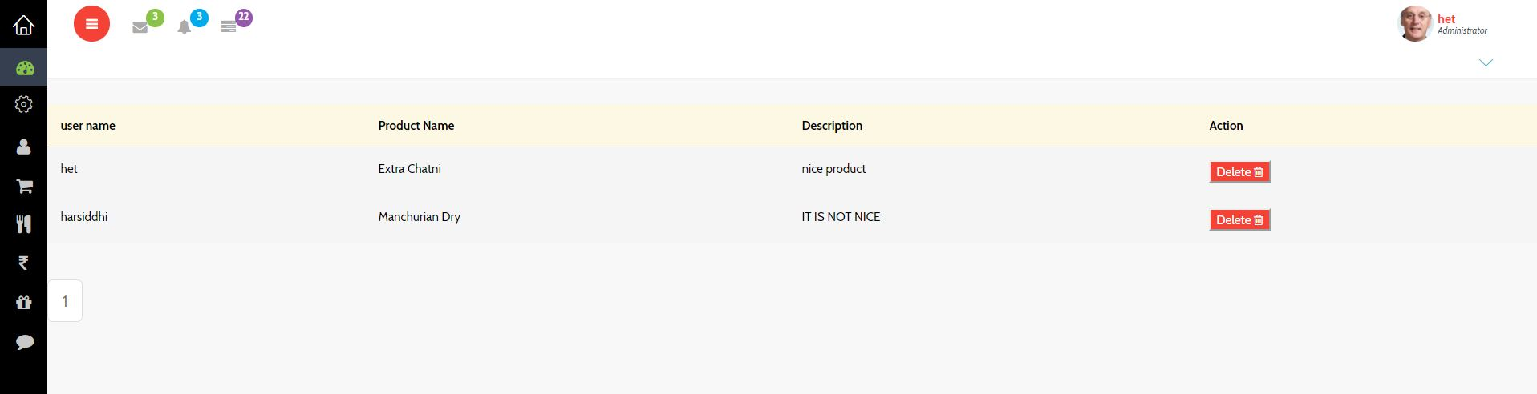

**Description:** This page shows all the feedback of the product which is given by the users.

* 1. **User side**

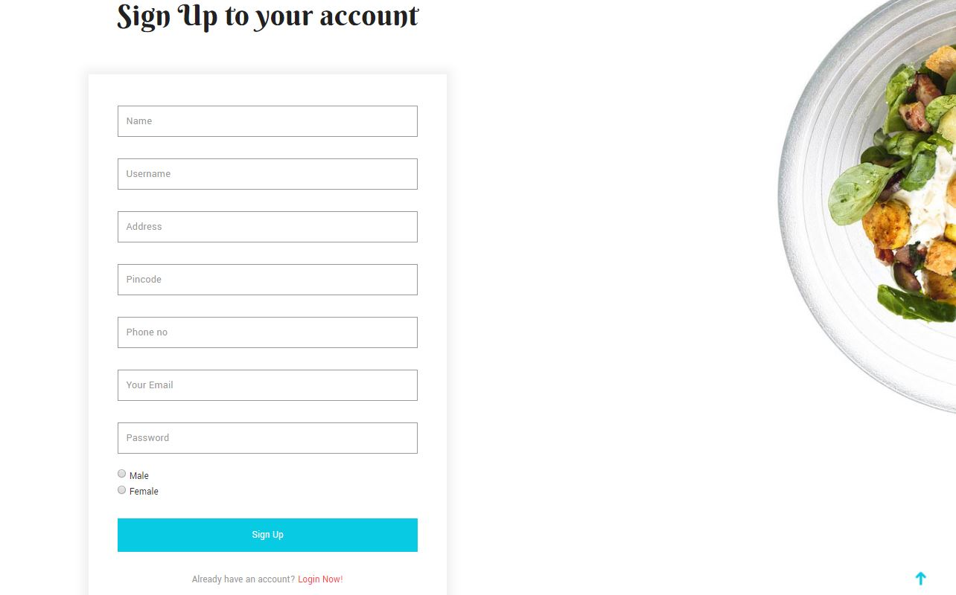

**Description:** This is sign up page for the new users to log in our site.

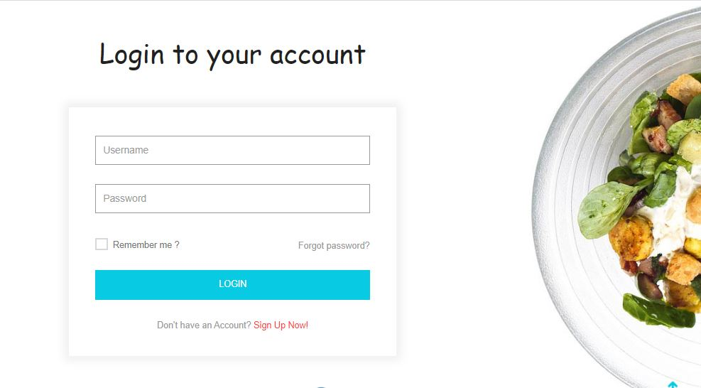

**Description:** This is log in page of the user side.

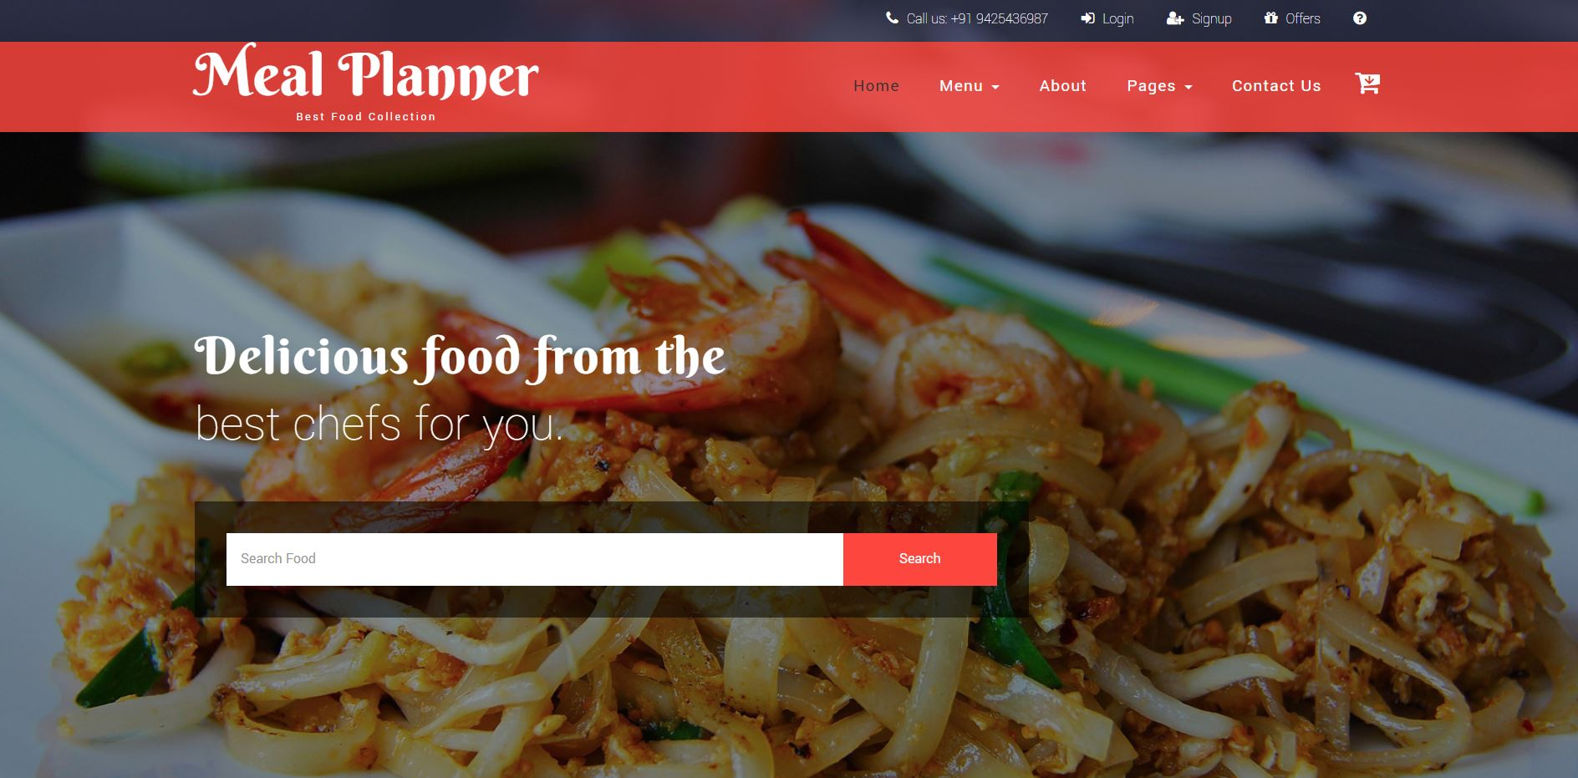

**Description:** This is dashboard of user side.

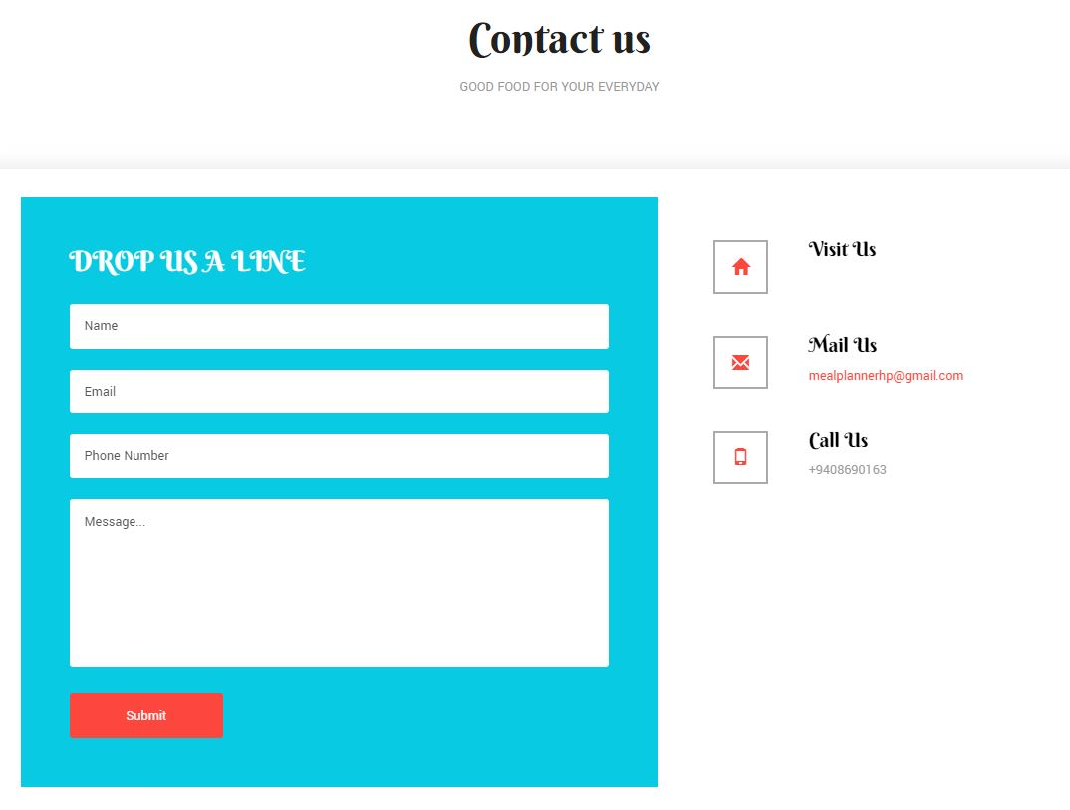

**Description:** If any user has don’t understand or any issue about our site then user contact with us using this page.

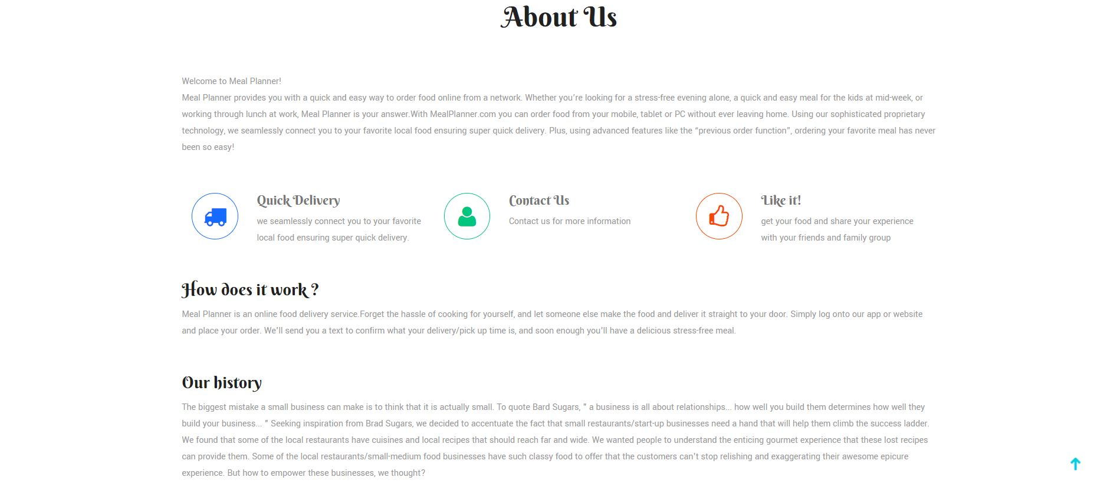

**Description:** This page shows details of our site for the users to understand about our work.

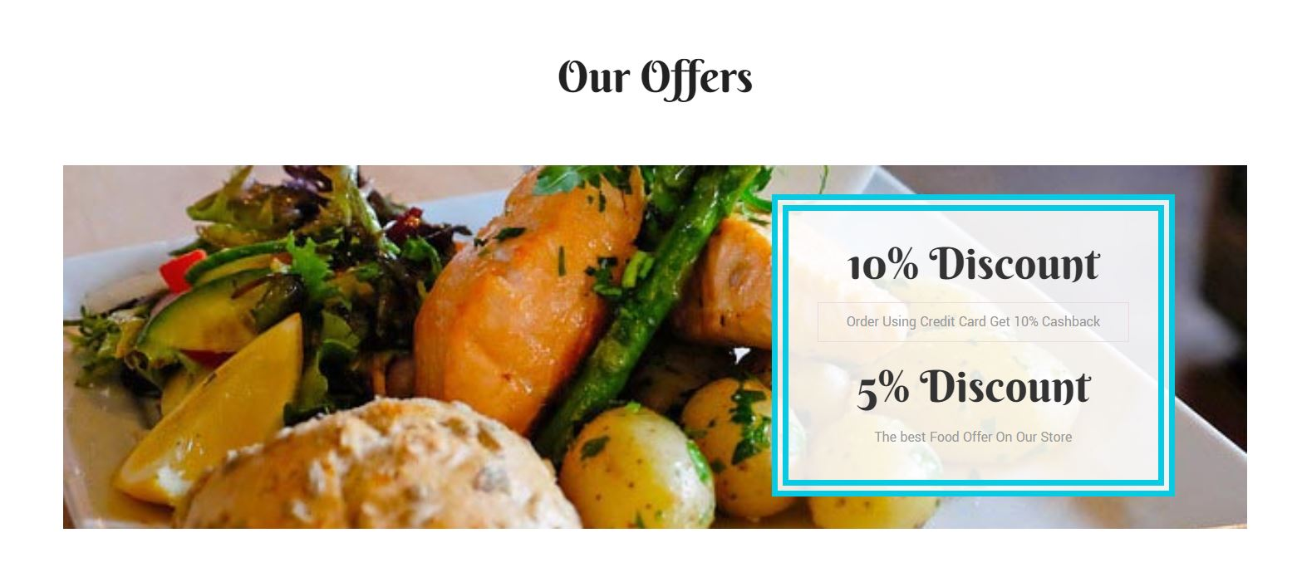

**Description:** This is offer page to attract the user for ordering the products.

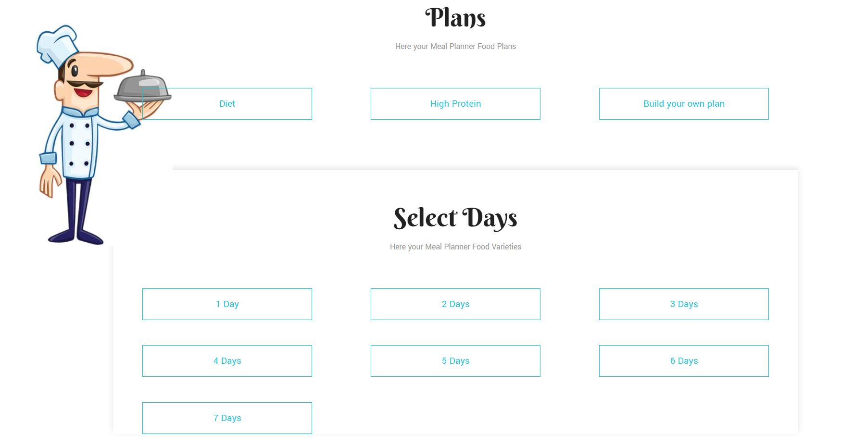

**Description:** This page is provide for user to select any plan and select days.

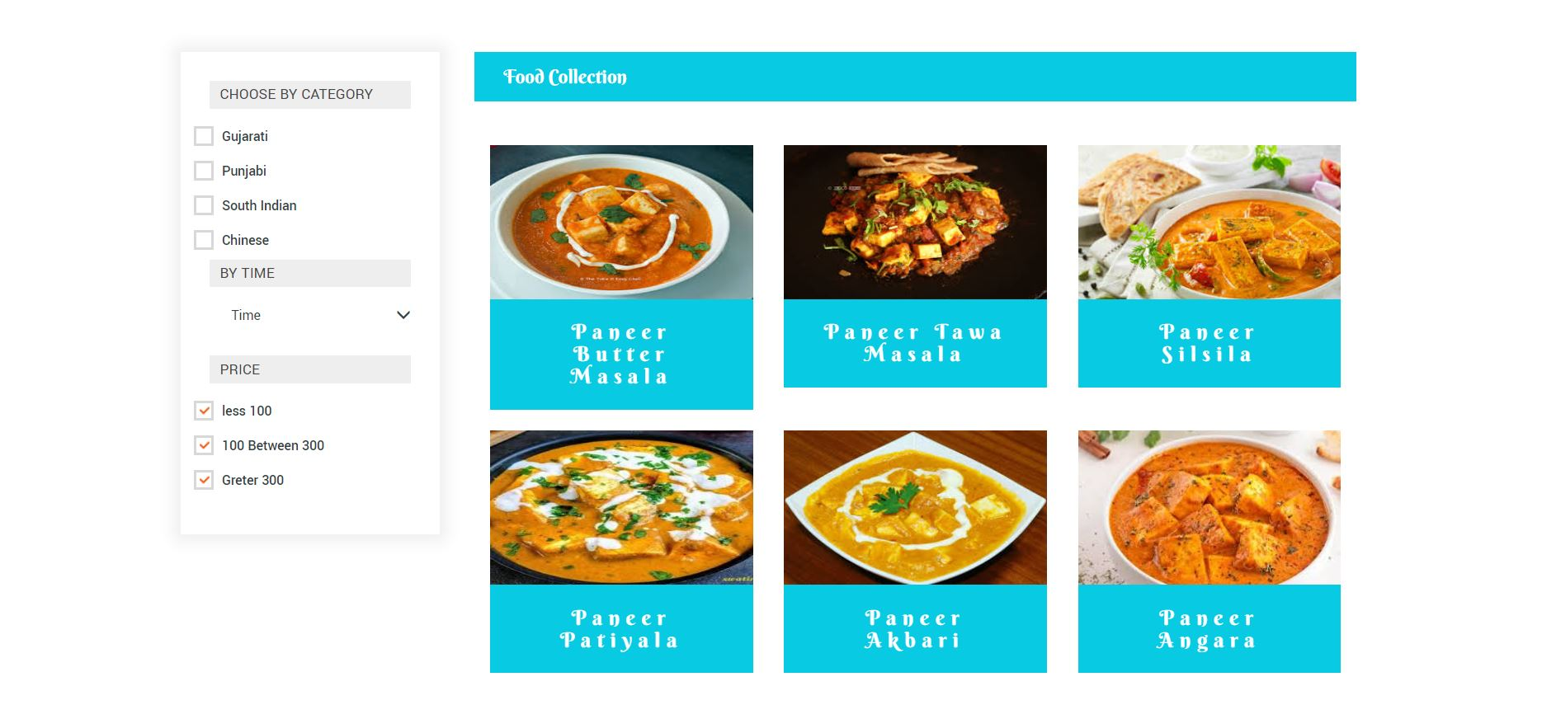

**Description:** This page shows products category wise.

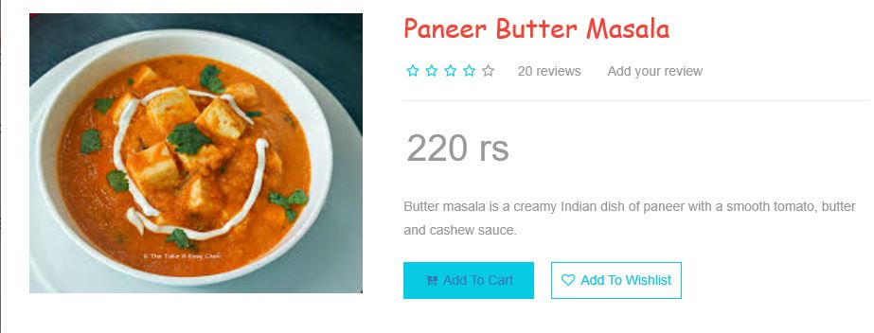

**Description:** when user click on any product then this page is appear to show all the details about the product.

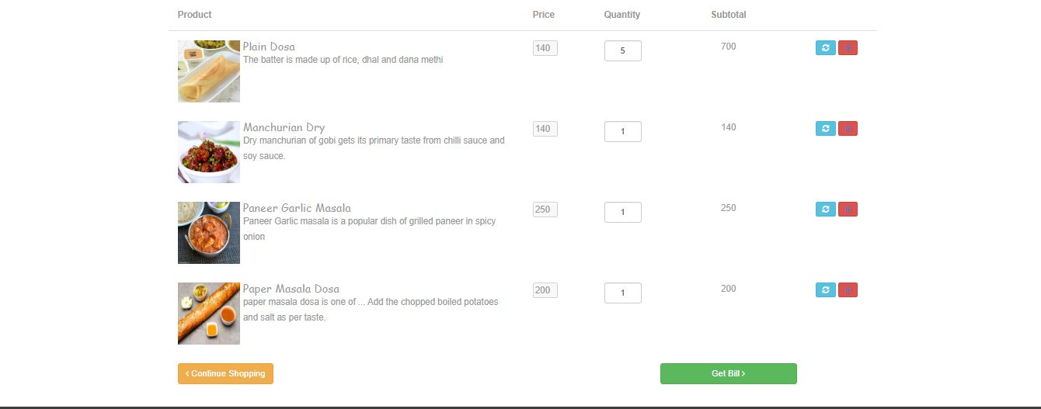

**Description:** This page shows the details of product that user want to purchase from our site.

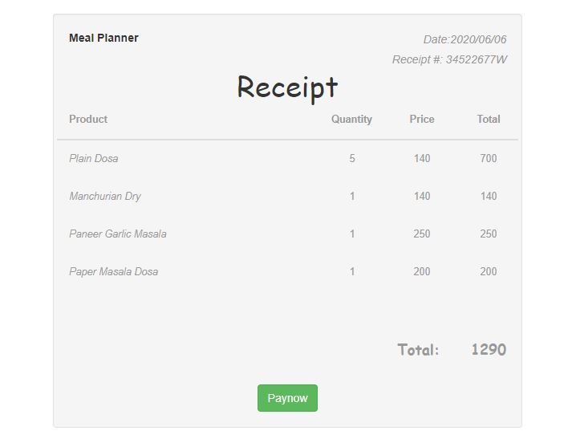

**Description:** This page show receipt of the all the product which user order.

Chapter: -6

Testing

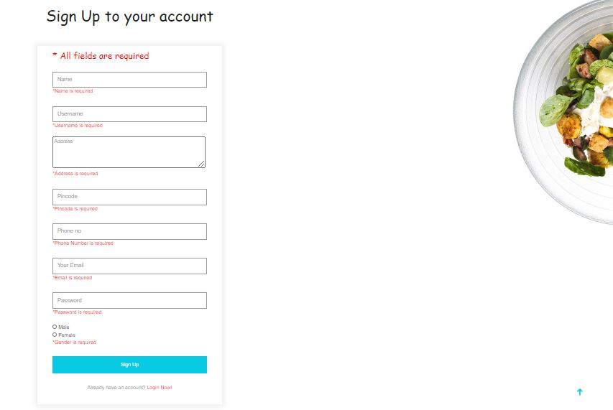

**Description:** All fields are required for sign up.

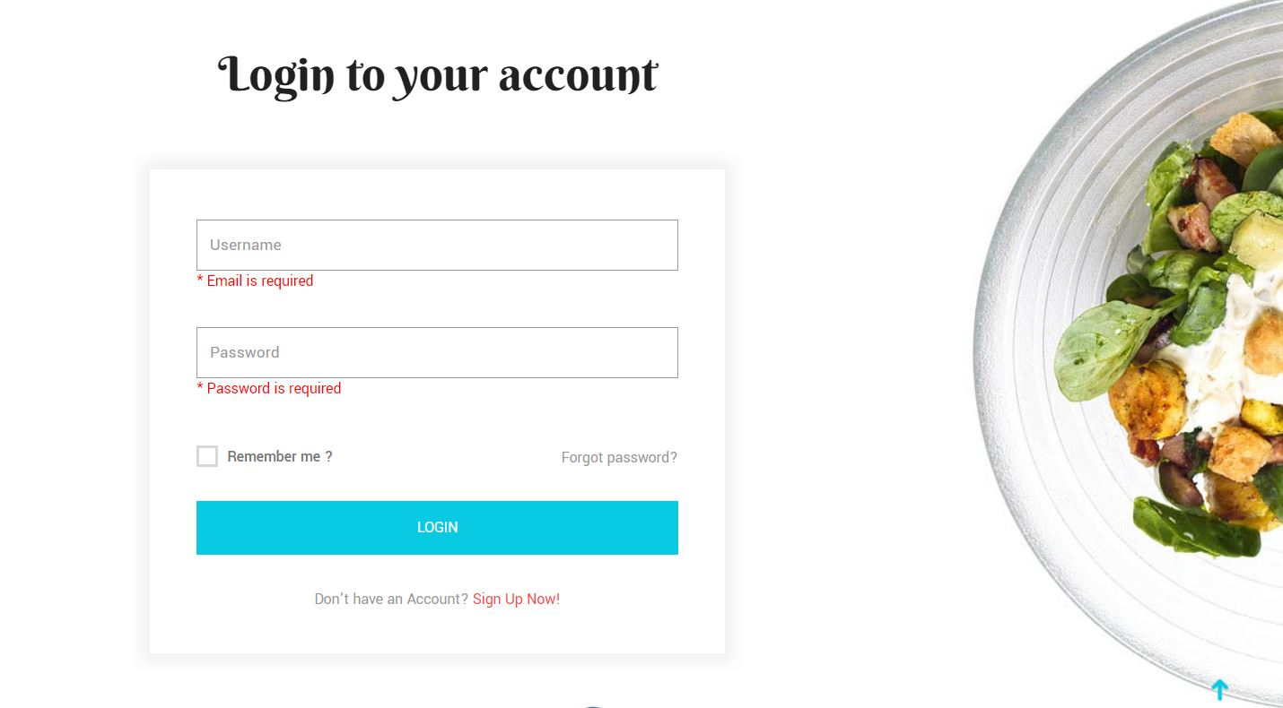

**Validation:** Username and password are required for log in.

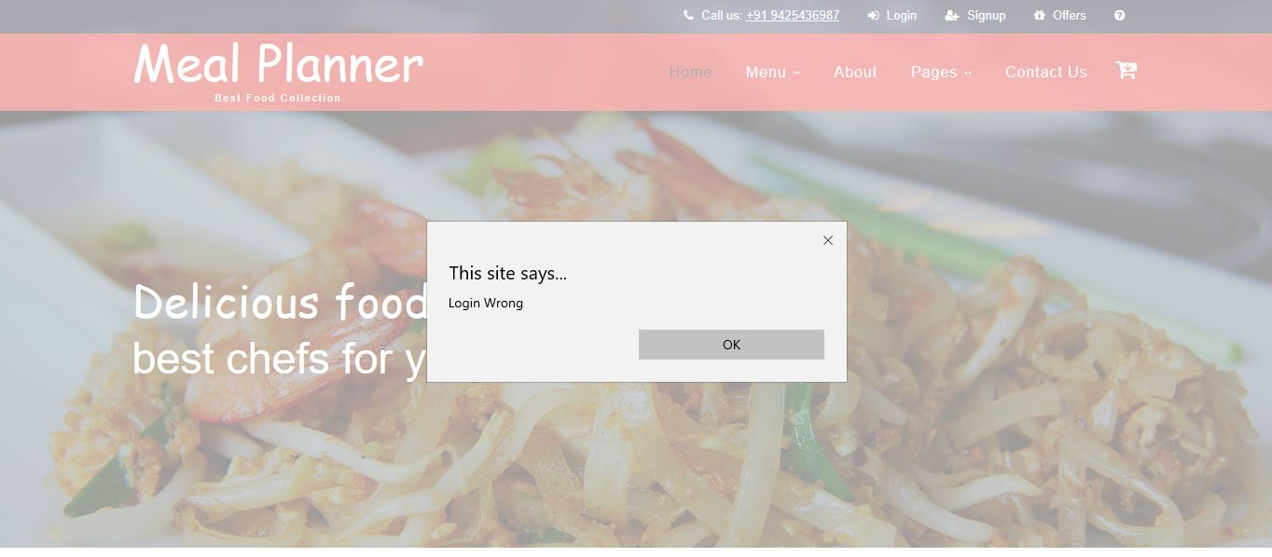

**Validation:** Wrong username or password for log in.

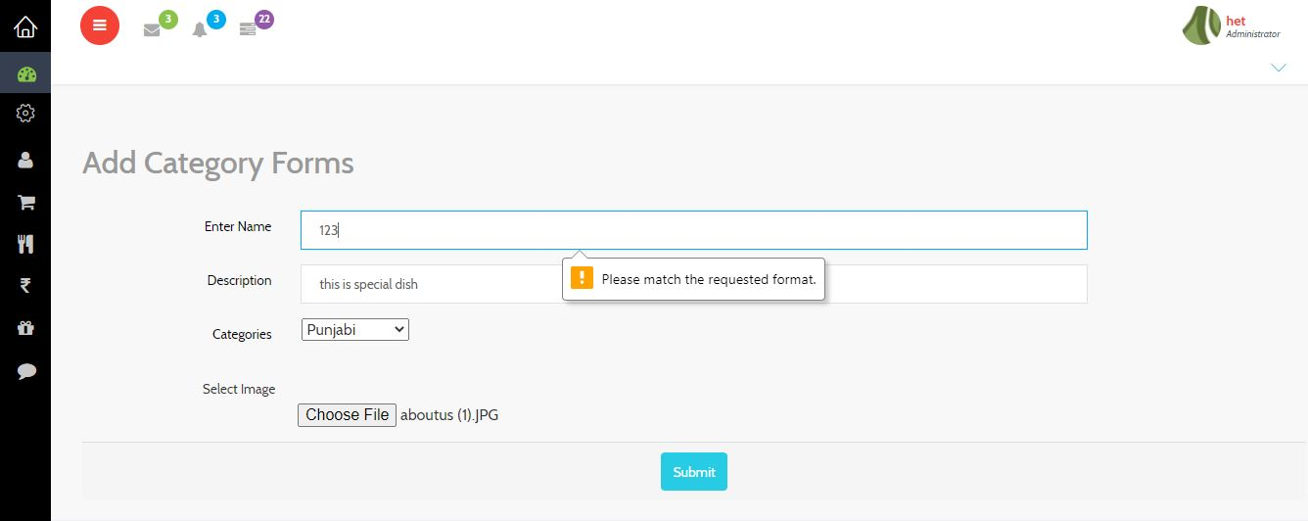

**Validation:** Name cannot be in number so this validation for request to follow the correct format.

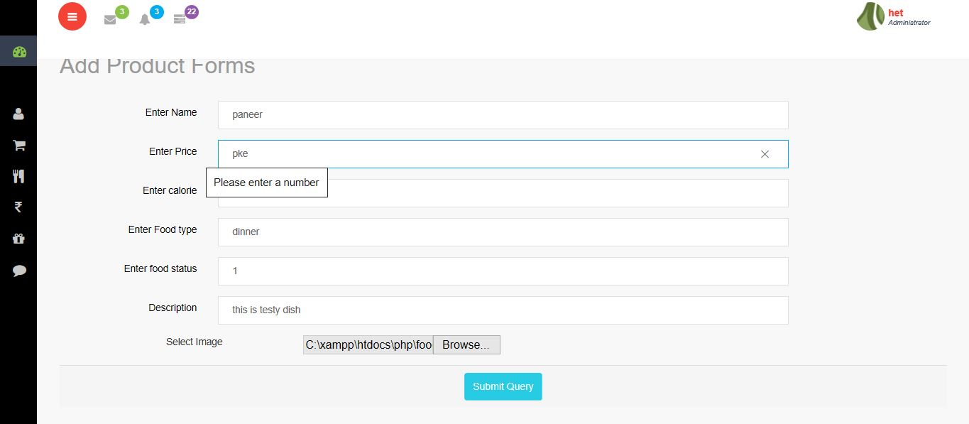

**Validation:** price cannot be in alphabet, enter the number.

Chapter: -7

Summary

**7.1 ASSUMPTION:**

* We assume that the Customer will enter all the data as data entry based.
* We assume that the admin will correct values obtained from forms and register.
* We assume that the end users of this software are assumed to have basic level of computer knowledge. I.e. Submit, Point, And Click.
* We assume the user experience and building our brand image with the help of reviews so we can considerably improve your sales too.
* We assume that customer having satisfaction after using this website.
* We assume that customer will give us otp after registration for confirmation their account.
* Customer can select plans and select categories.so we assume that they have knowledge of the all products and plans.

**7.2 Limitation: -**

* Each system has its own measures of successes and failures, as well as its critics.
* We must realize that there is no perfect system. Since we just want to try to build software that describe us how the data /information in meal planner system is managed.
* We have included few modules in our project .so, this project has limitations in some areas.
* Major limitations can be as our system is not language savvy so if few people don’t understand the English language then this prove as a limitation to our system.
* Chances of technical problem in the system.
* We cannot have tracking system so user cannot trace the locations of order.
* Huge numbers of competitions.

**7.3 Future Scope: -**

* Now we are making the system for only one Restaurant but in future we may be add more seller in our website.
* We will add more plan in our website.
* We will add cash on delivery option in our website.
* We will add live tracking for food delivery in our website.
* In future this system can allow multiple branch for one seller.

## 7.4 Conclusion:

* The main purpose of this site is to allow customers to place order without even visiting the shop. Being able to order any time, any place, anywhere.

* Online food ordering become easier than real-world.
* We also provide meal day by day so customer can order for more than one day with one-time order.

**Bibliography:**

1. Roger S Pressman, “Software Engineering  -A Practitioner’s approaches”

            McGraw -Hill International Editions Fifth Edition, 2001.

1. Magnifying Object-Oriented Analysis and Design -Arpita Gopal, Netra patil.
2. <https://w3layouts.com/>
3. <https://getbootstrap.com/>
4. <https://fontawesome.com/v4.7.0/icons/>